**Test plan**

**Programme Title**

**Students Name**

Bachelor of Information and Communications Technology (Database System/ Programming) ICT8040/ICT8010

202000270 – 202002514 – 201901982 – 202003580 - 202002172

Amena Almohanna – Fedaa Abdulwahab – Maryam Alali - Sara Abdulrahman – Ebtisam Alanfooz

**Students ID**

**Lecturer’s Name**

Saba Mustafa

**Table of Contents**

**Home page** 3

**Login** 3

**Sign Up** 4

**Logout** 5

**Searching** 5

**Admin Dashboard** 12

**Manage Employees(Add/Edit/Delete)** 13

**Manage Halls(Add/Edit/Delete)** 15

**Manage Clients(Add/Edit/Delete)** 18

**Manage Catering(Add/Edit/Delete)** 22

**Manage Reservations(Edit/Delete)** 24

**Employee portal** 24

**Client portal** 25

# **Home page**

This is the homepage for an Online Event Management System. The design is straightforward and functional, featuring a header with navigation bar for "Home," "Sign Up," and "Login" and footer with copyright. The view will be the same for all the visitors.

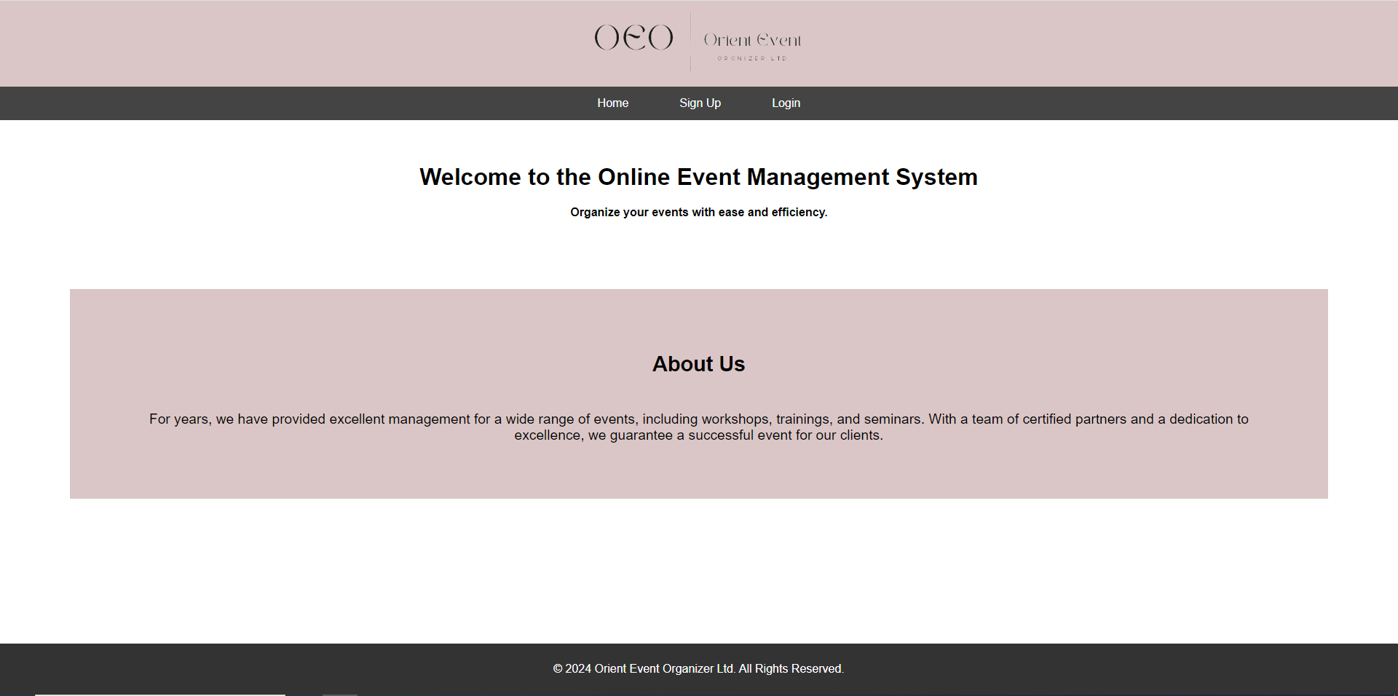

# **Login**

The login page for the Online Event Management System. After clicking on Login button, a login page will appear allowing existing users to access their accounts and manage their events efficiently by entering their username and password.

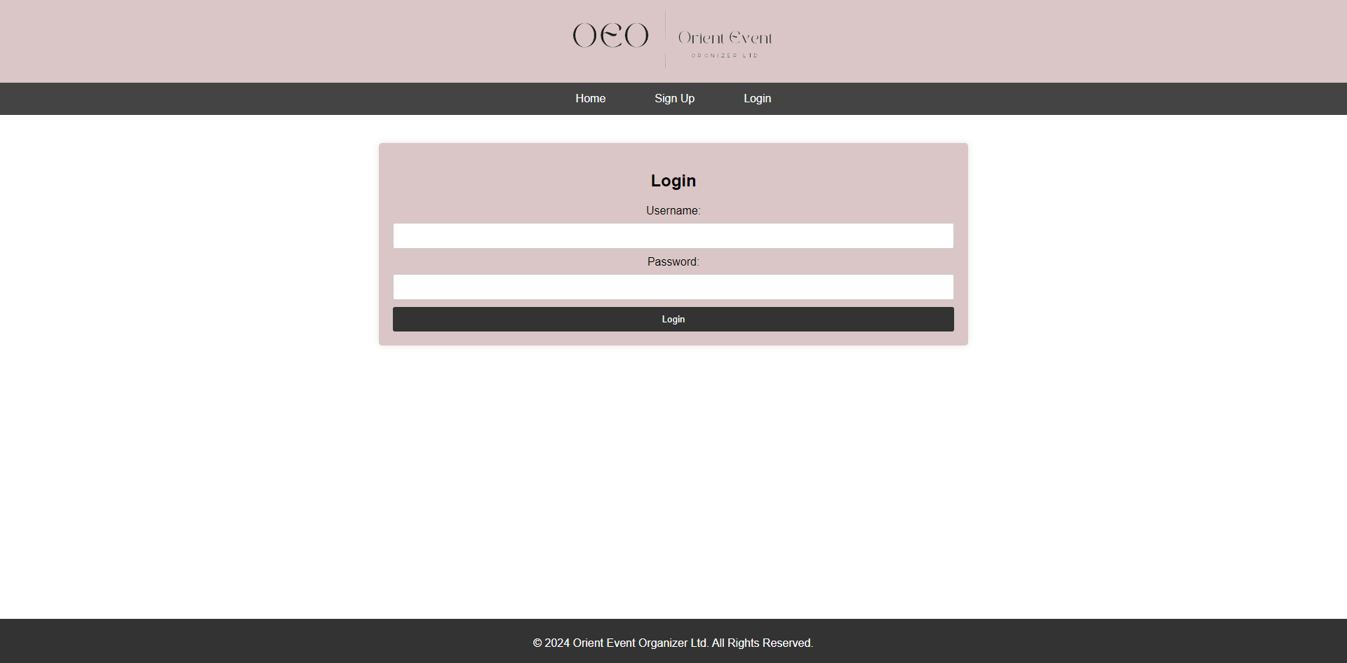

## **Sign Up**

This is the sign-up page for the Online Event Management System. The main section contains a registration form with fields for "Username" "Password" and "Email" for Admin, Employee and Client users to create an account.

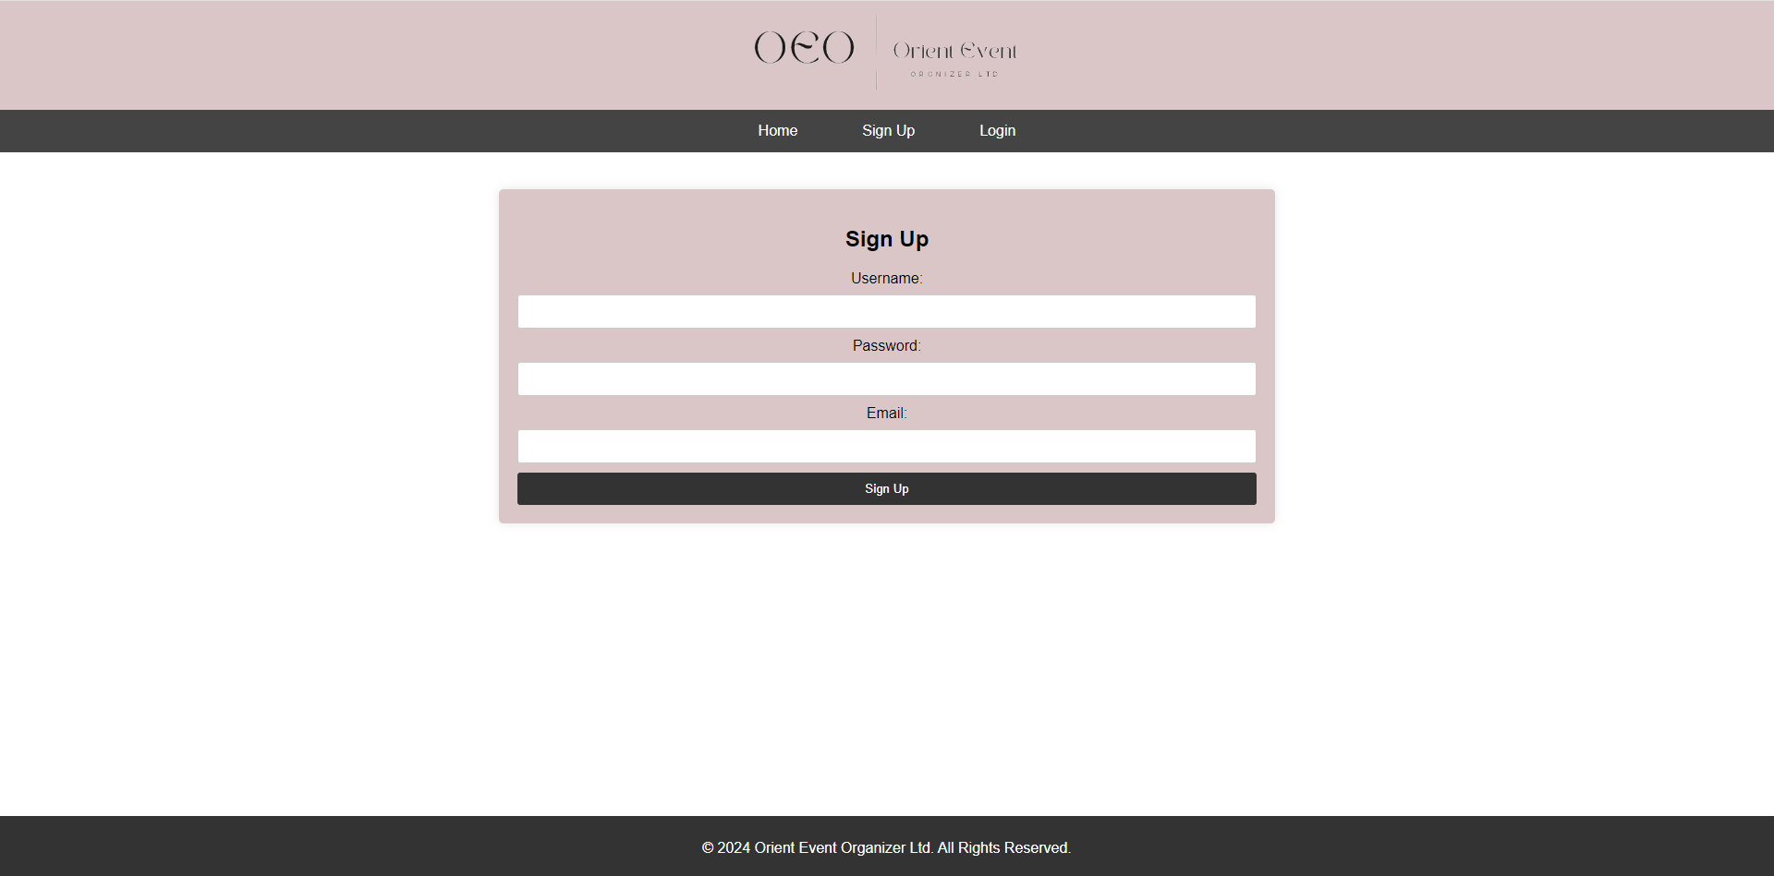

## **Logout**

When clicking on the “Logout” button, the user account will be logged out and it will be redirected to the home page.

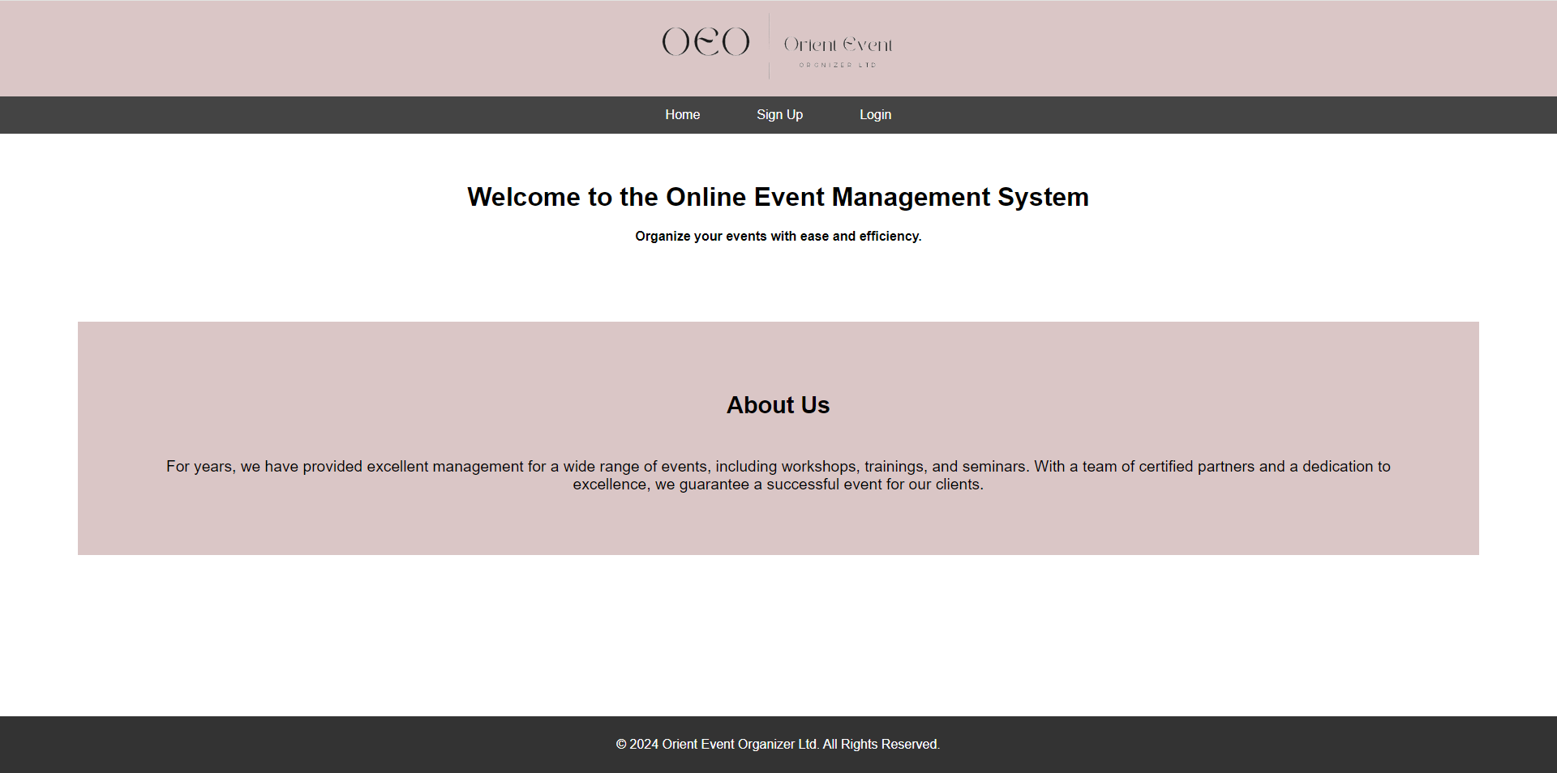

# **Searching**

The user will be able to search and advance search after clicking on the “Halls” button. Simple search by entering a text. Advanced search by choosing specific criteria such as date, location, and number of people.

The list of available halls that shows after the user clicks the search button changes based on the availability of the hall on the specific dates. So, if another user has already reserved a hall it will not show in the list. Moreover, the availability is included in the database as an attribute. It can either be 1 for reserved, or 0 for available.

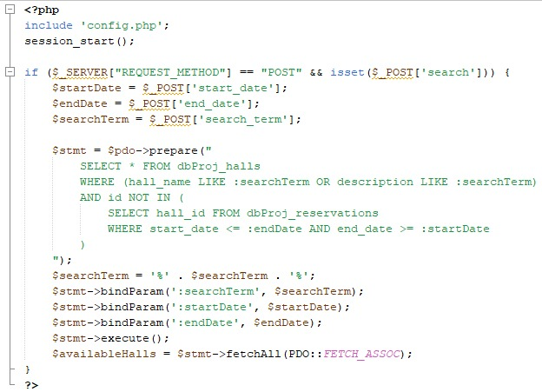

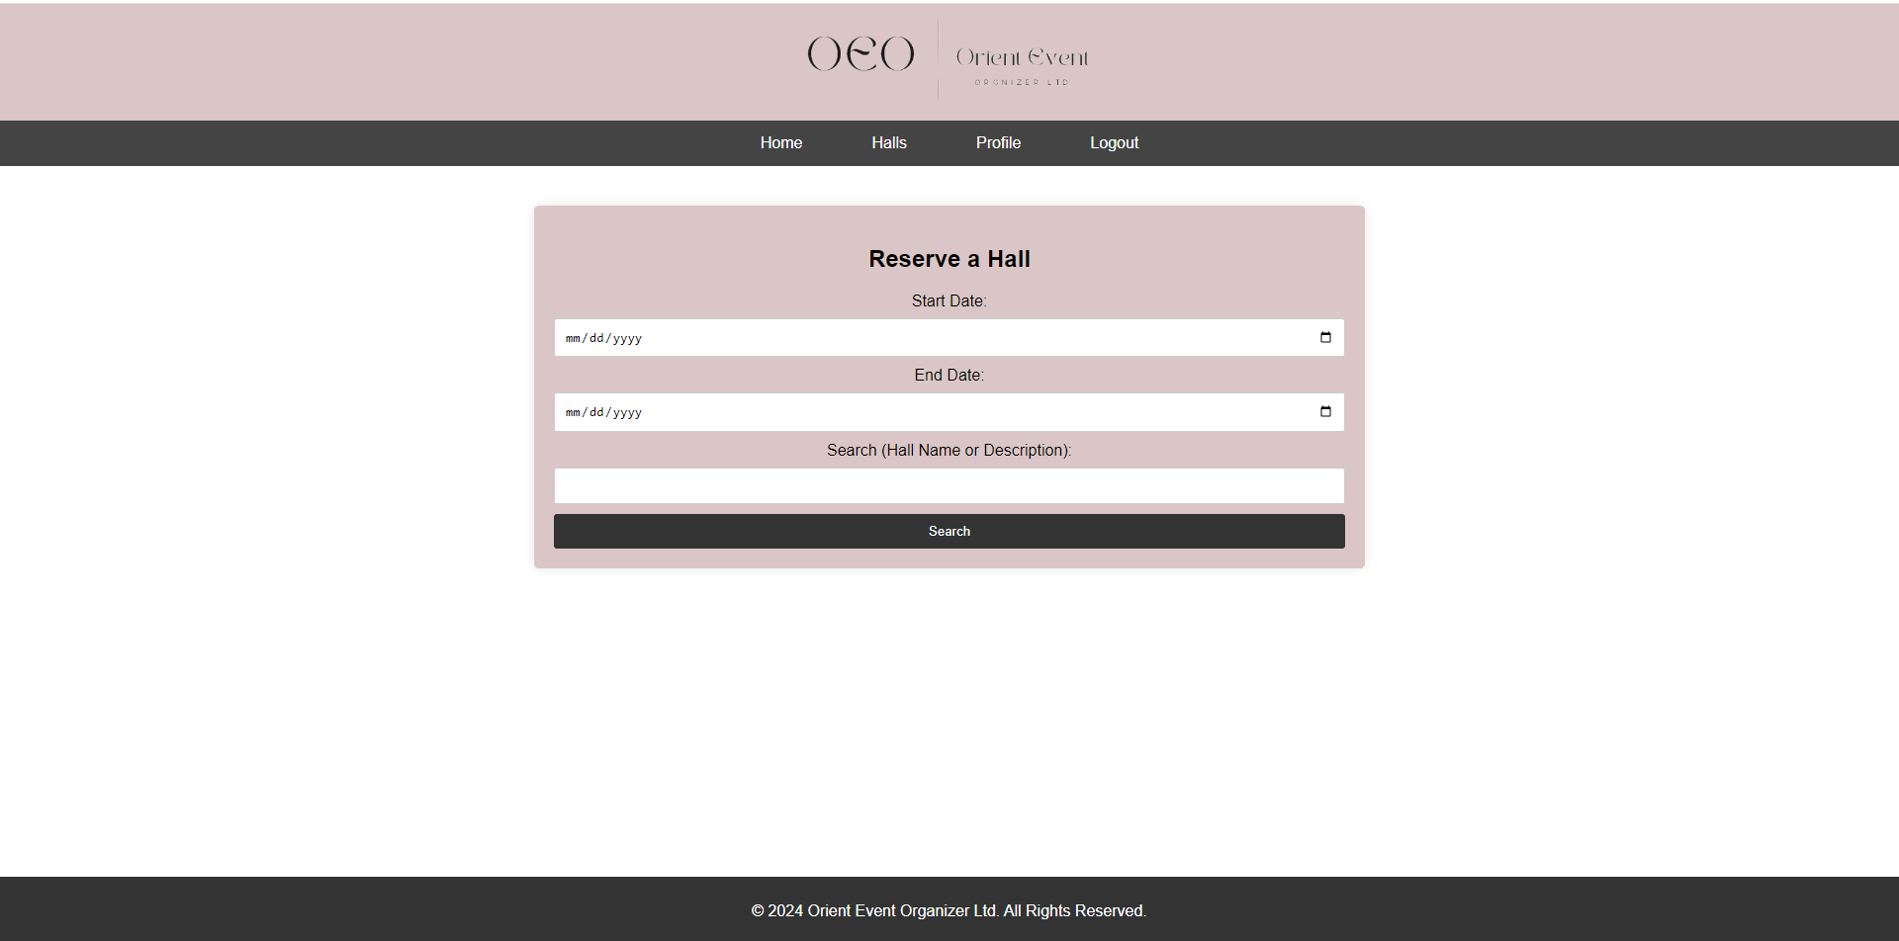

If search found:-

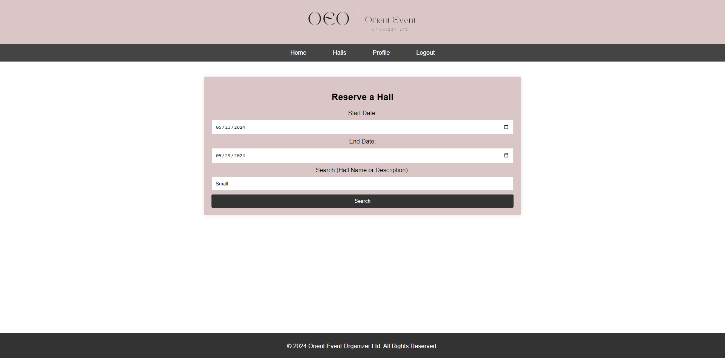

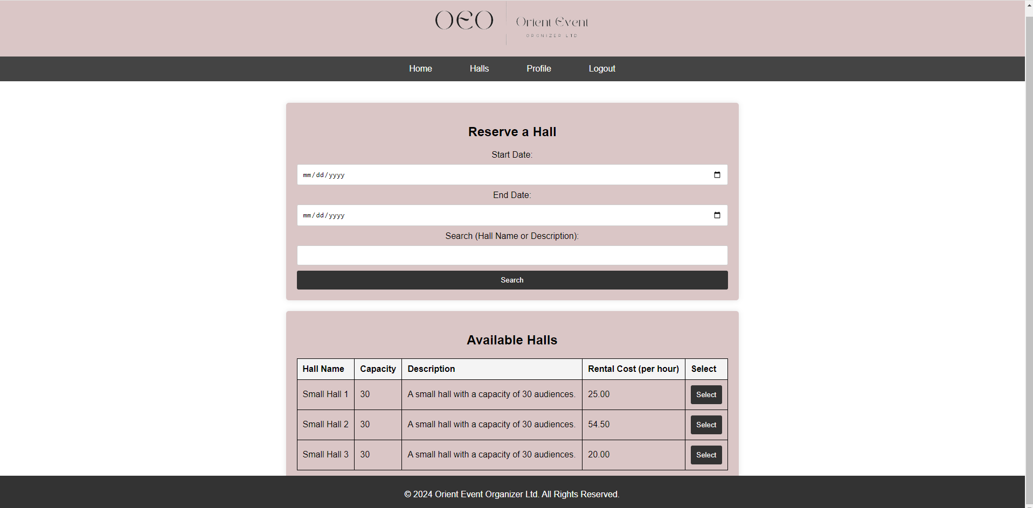

The image for the hall changes based on the selected hall’s capacity, between 1 to 35 is small, 36 to 79 is medium and 80 or more is big.

When clicking on “Select” Button of the Computer Lab:-

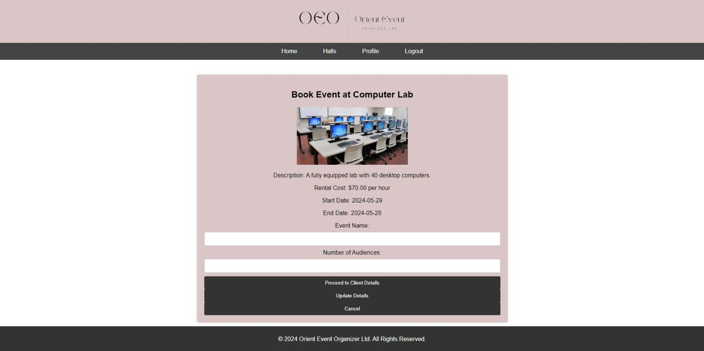

When clicking on “Select” Button of the seminar hall:-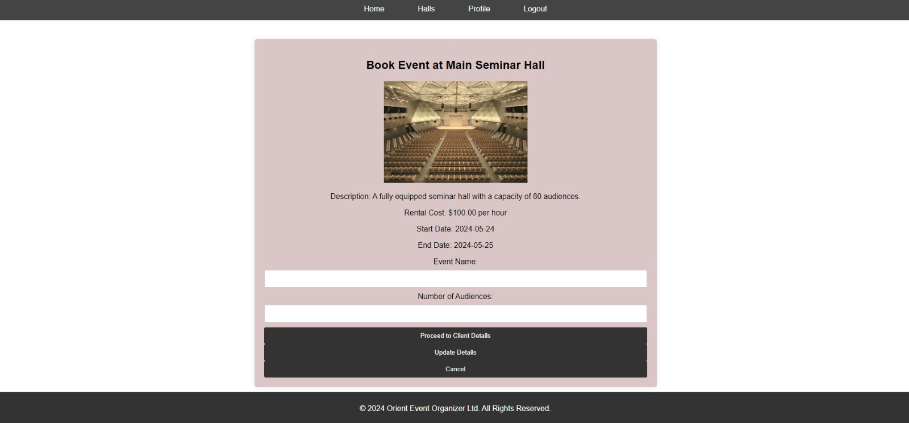

When clicking on “Select” Button of the small hall:-

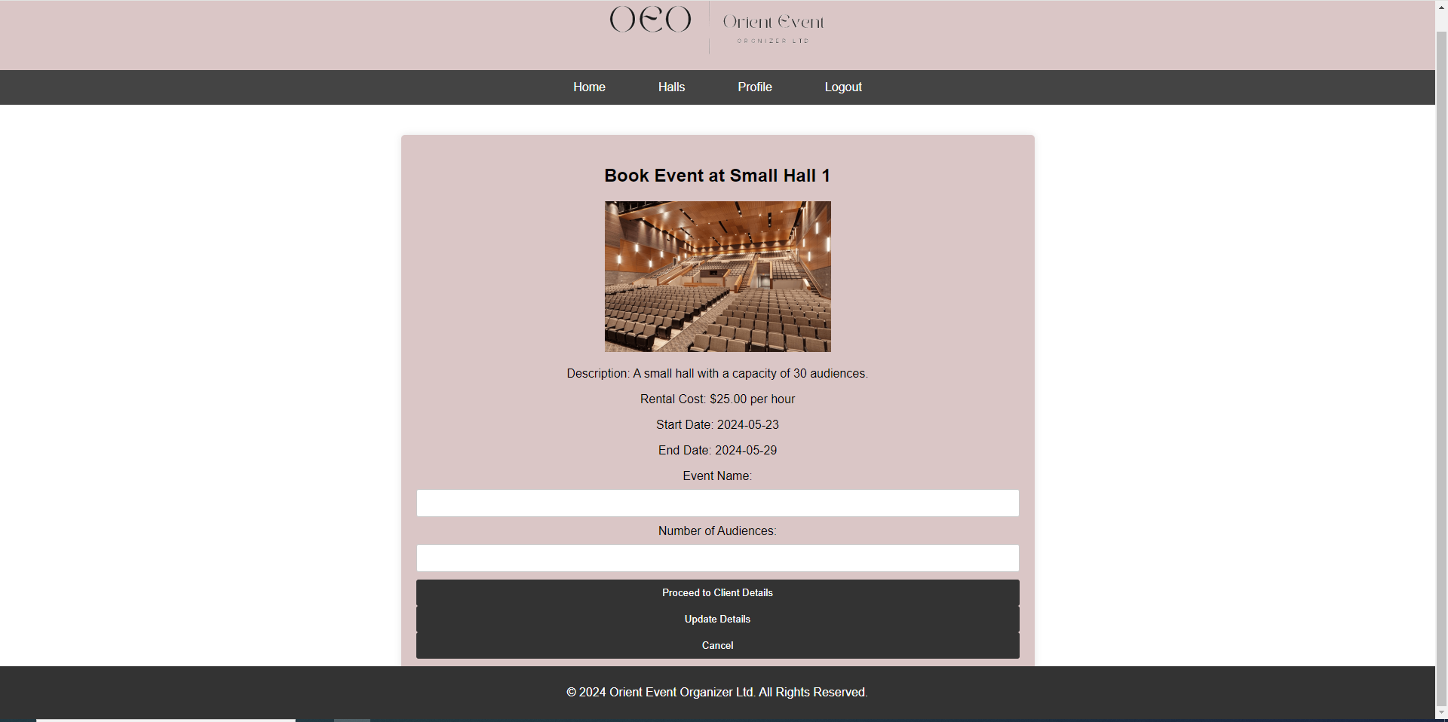

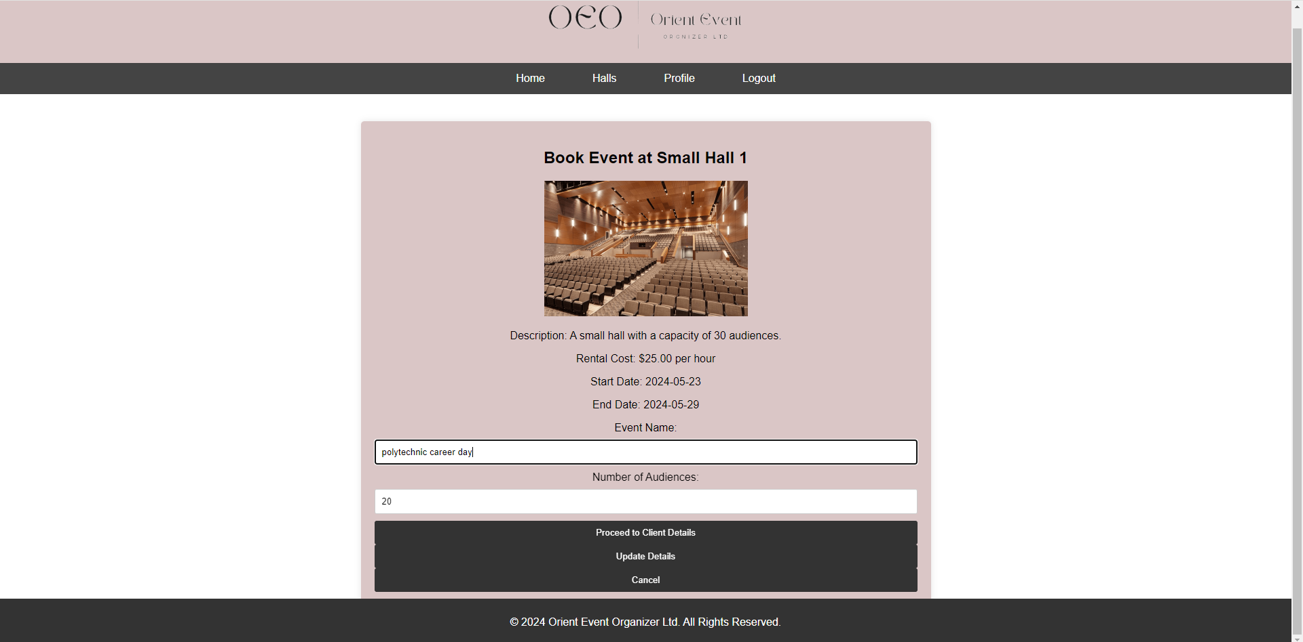

Clicking on “Proceed client details” button:-

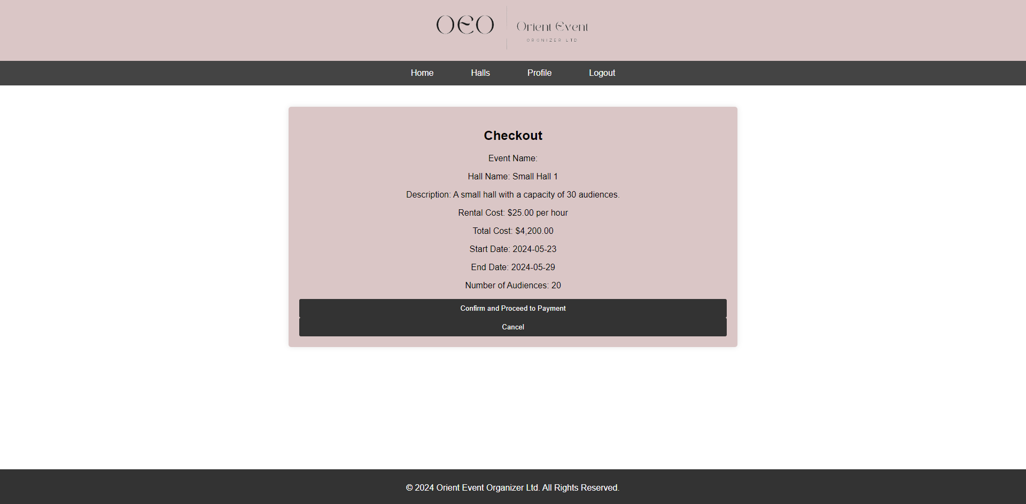

Clicking on “confirm and proceed to payment”:-

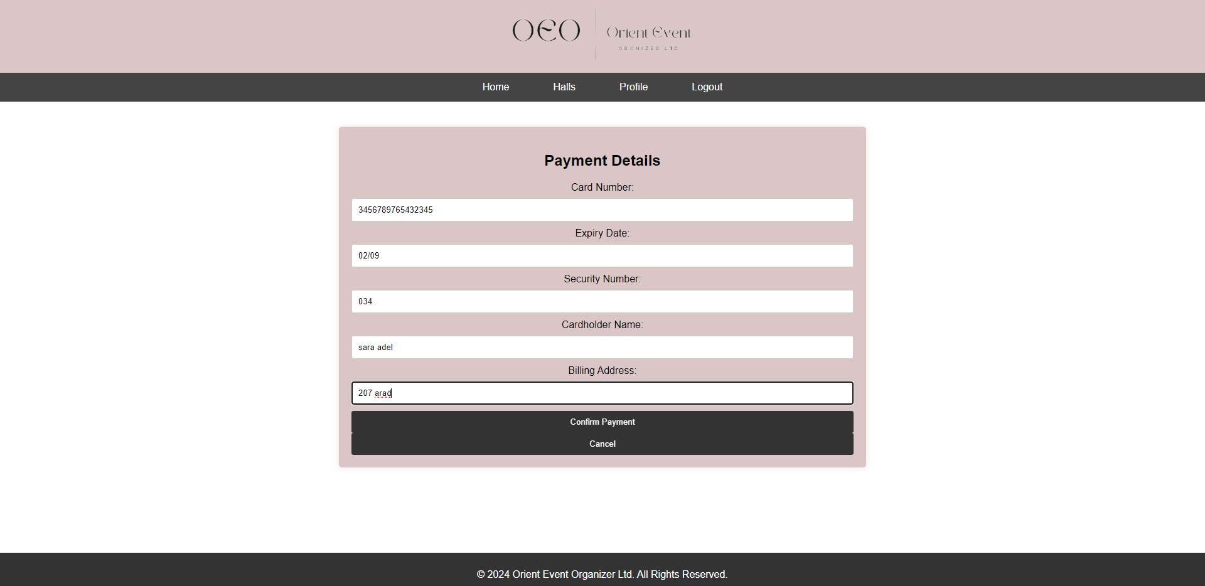

Clicking on confirm payment button:-

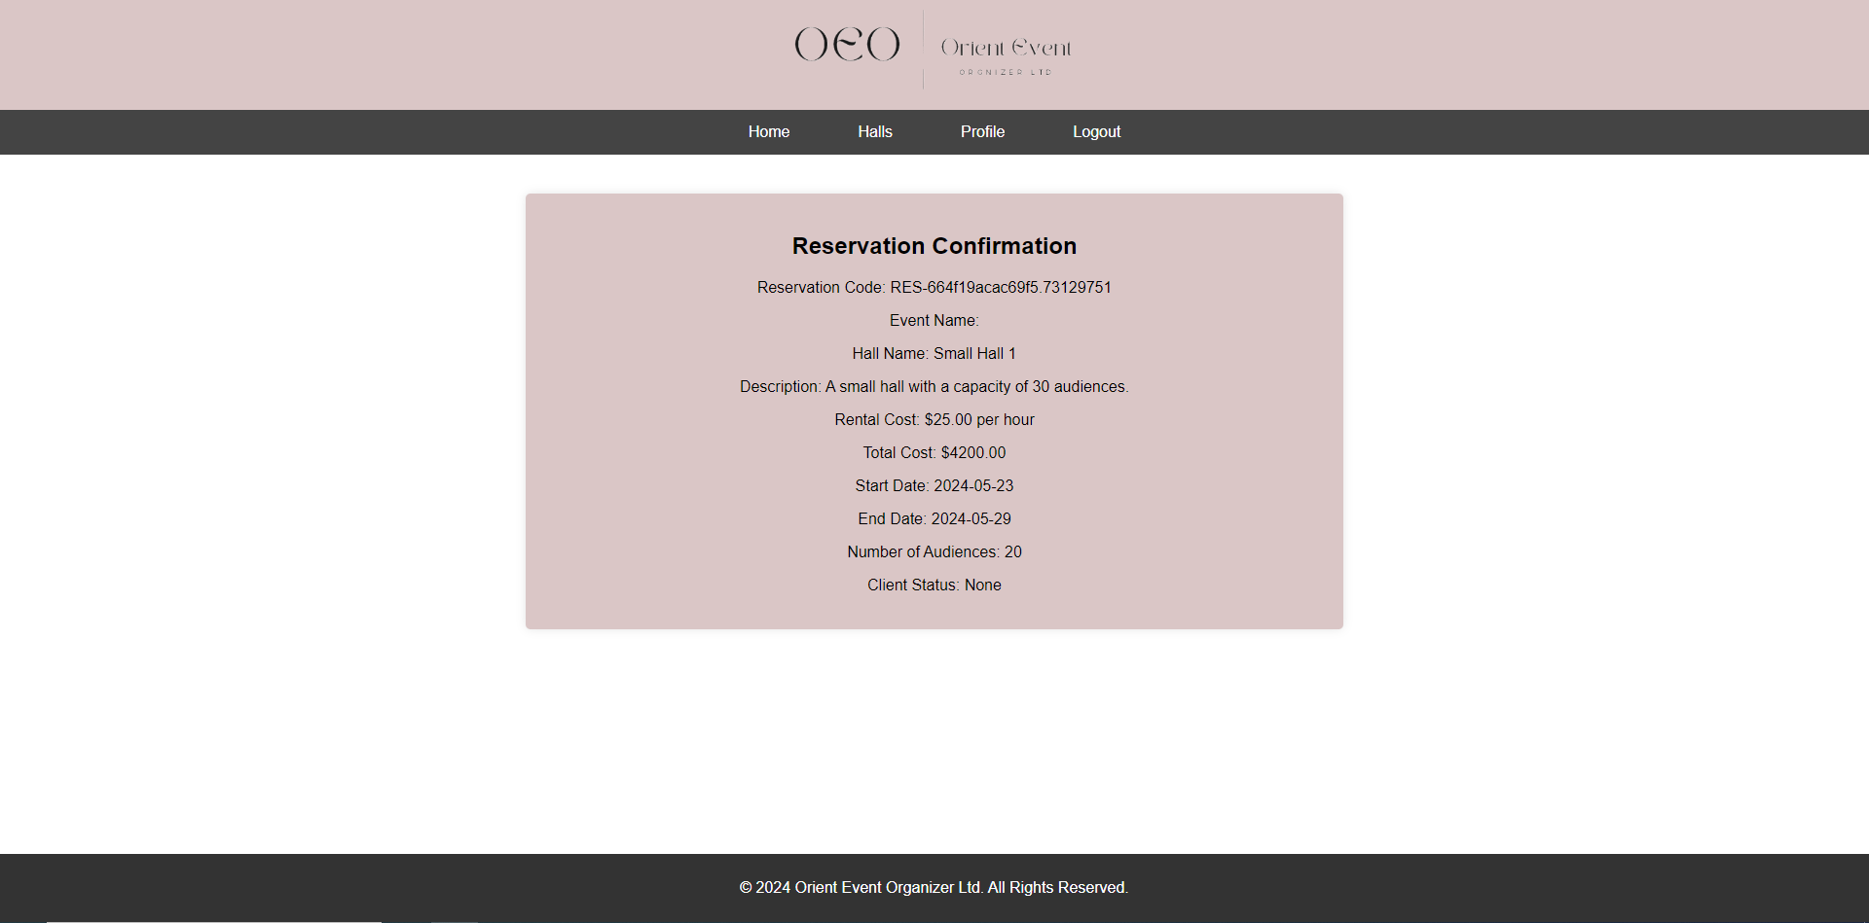

After payment hall reserved disappeared from view:-

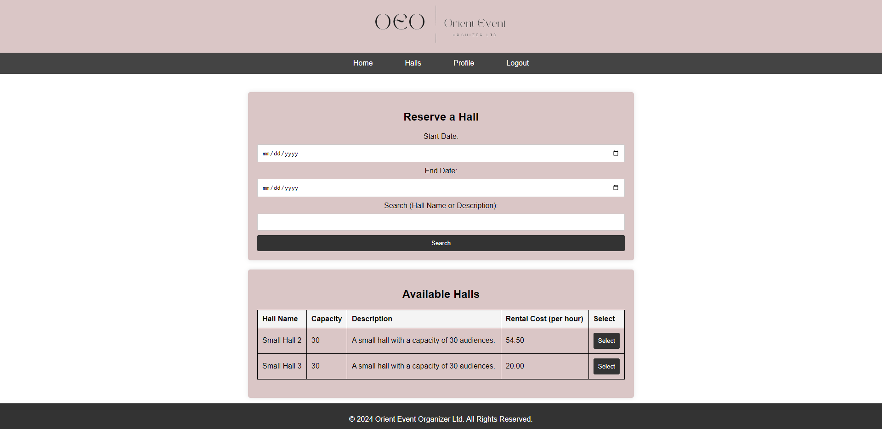

If search not found :-

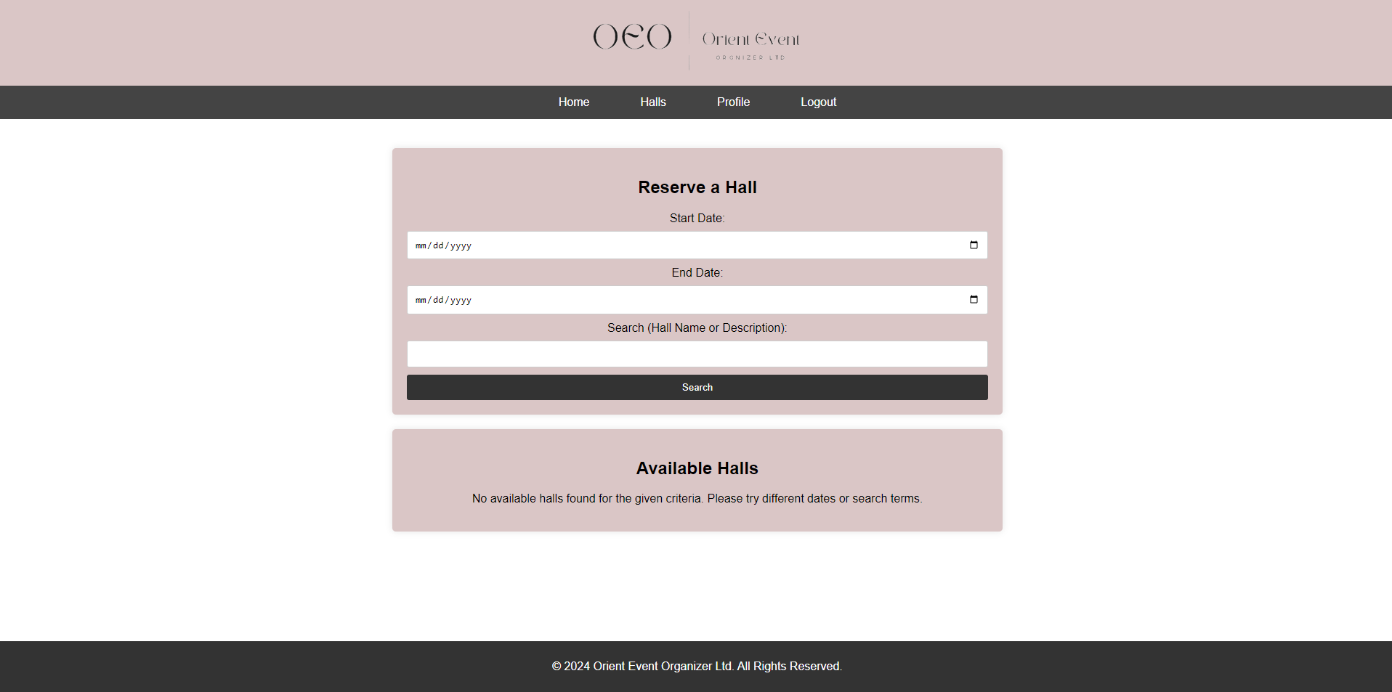

# **Admin Dashboard**

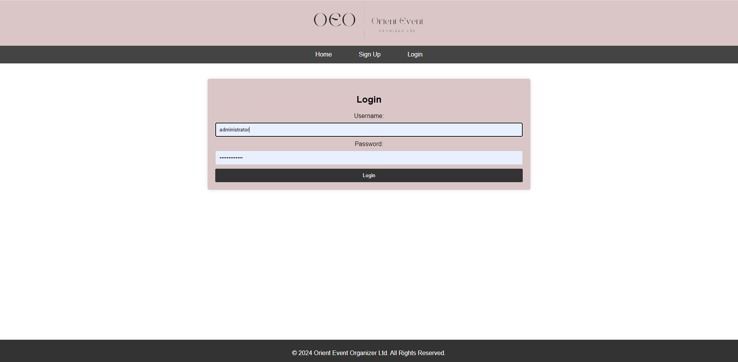

This is the admin dashboard page for the Online Event Management System. The design is easy to use, featuring a header with navigation bar for “Home”, “Admin Dashboard”, “Manage Employees”, “Manage Halls”, “Manage Clients”, “Manage Catering”, “Manage Reservation”, “Halls”, “Profile”, “Logout”. The main section welcomes users with a headline that reads "Welcome to the admin dashboard."

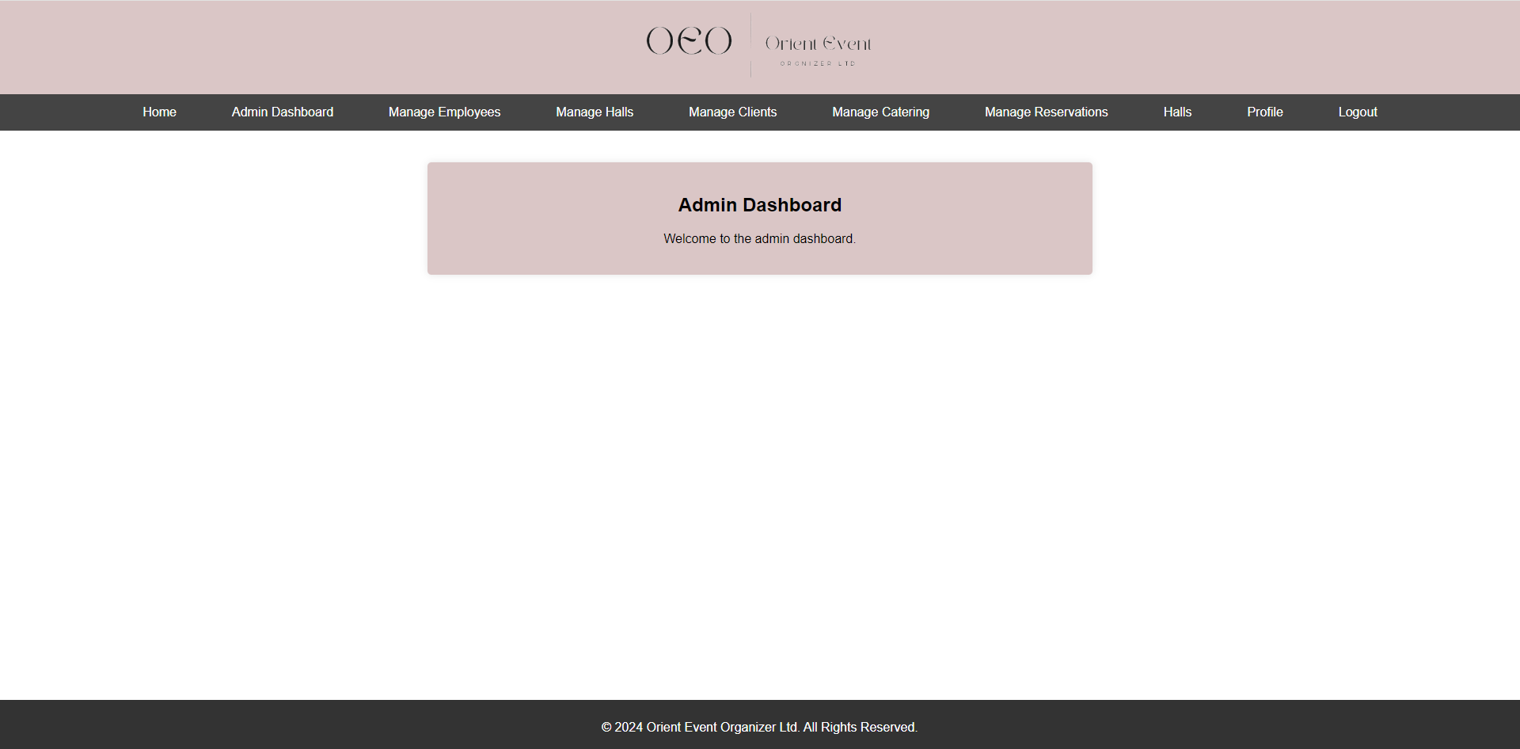

# **Manage Employees(Add/Edit/Delete)**

The “Manage Employees” page within the Online Event Management System provides the user with comprehensive tools to add, edit, and remove employee accounts and can easily access detailed employee information.

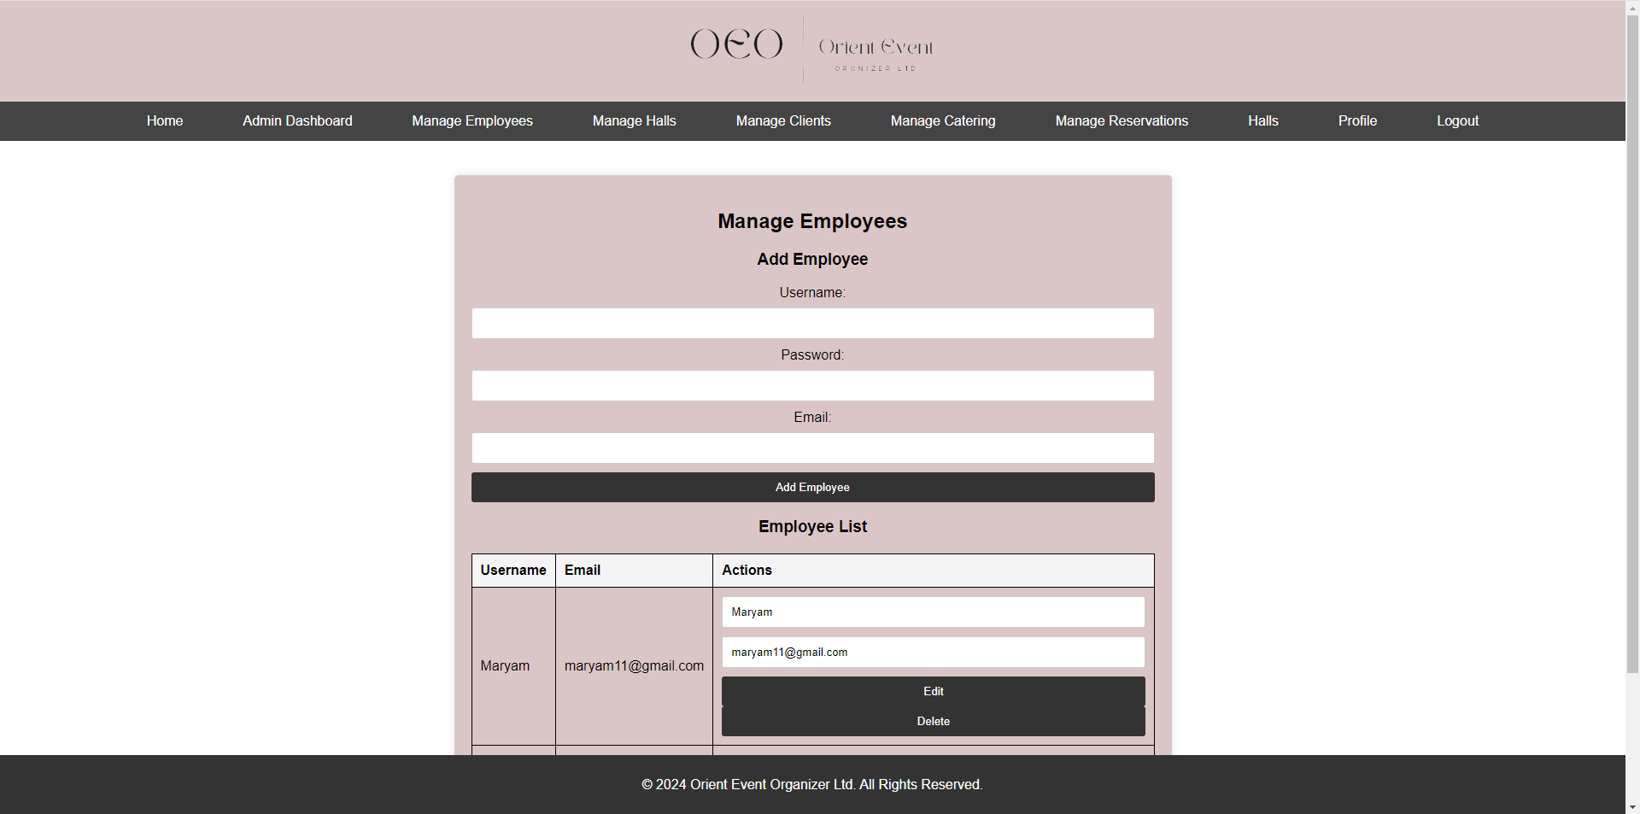

Adding employee information to add it to the employee list.

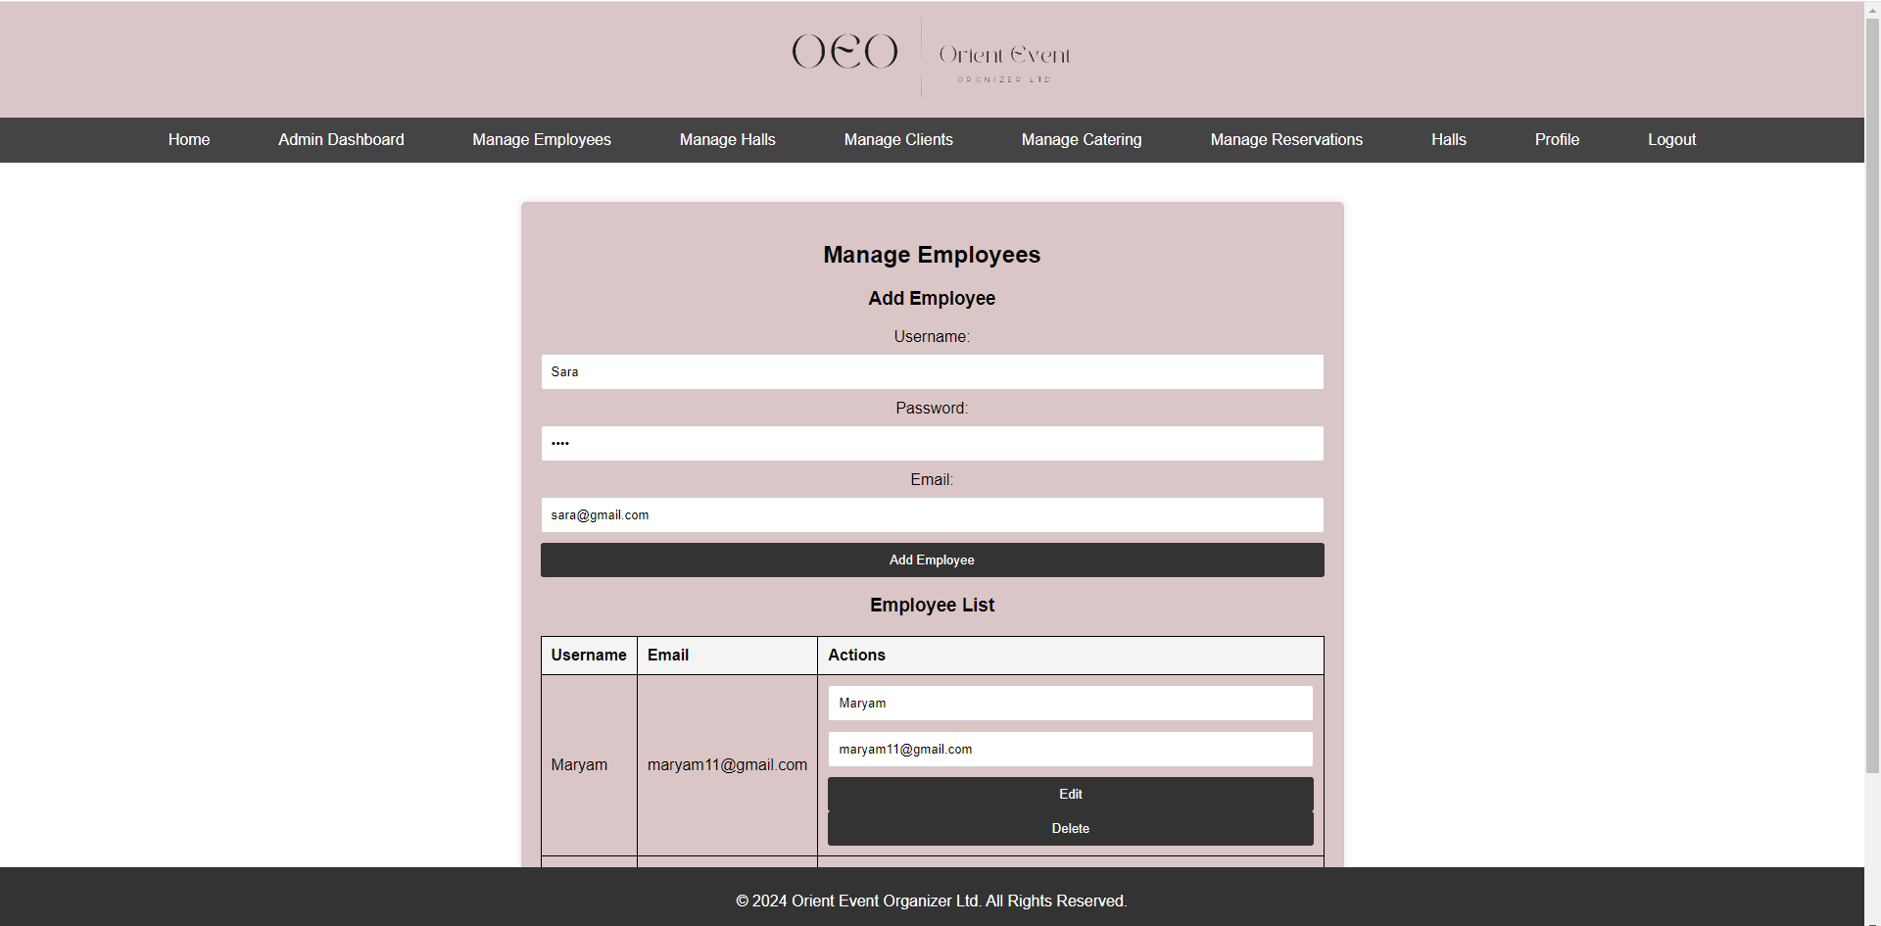

Added successfully

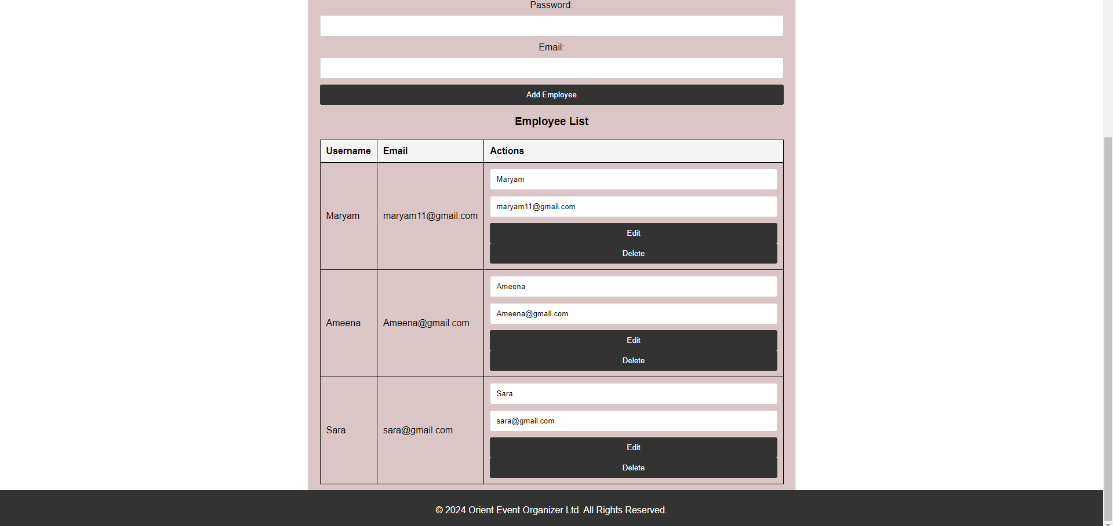

Edit employee



Edit succeffully:-

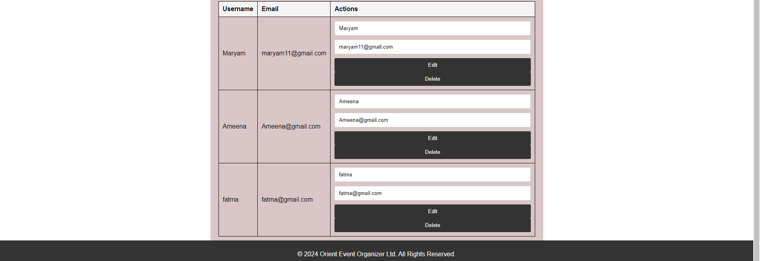

Delete Employee

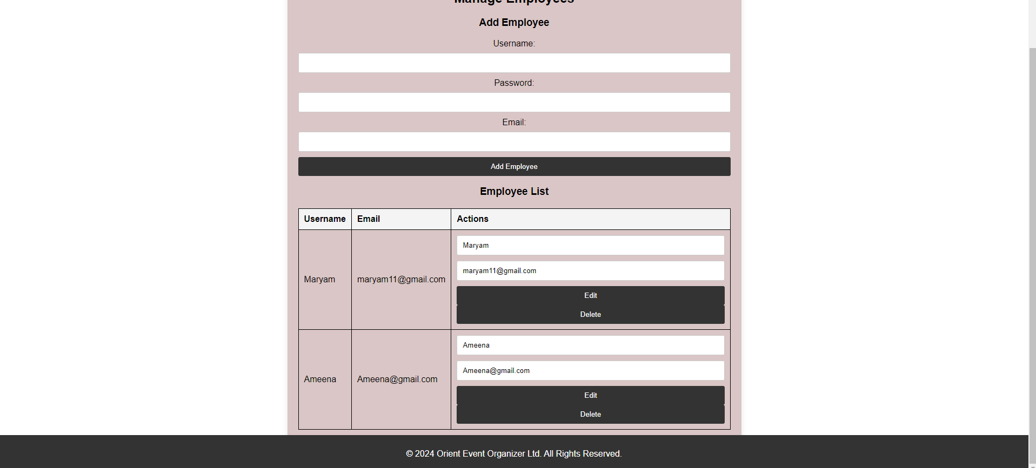

# **Manage Halls(Add/Edit/Delete)**

The “Manage Halls” page within the Online Event Management System allows users to add and view halls along with their attributes. This page features an action section where users can edit or delete specific halls, providing a streamlined interface for efficient management of event spaces.

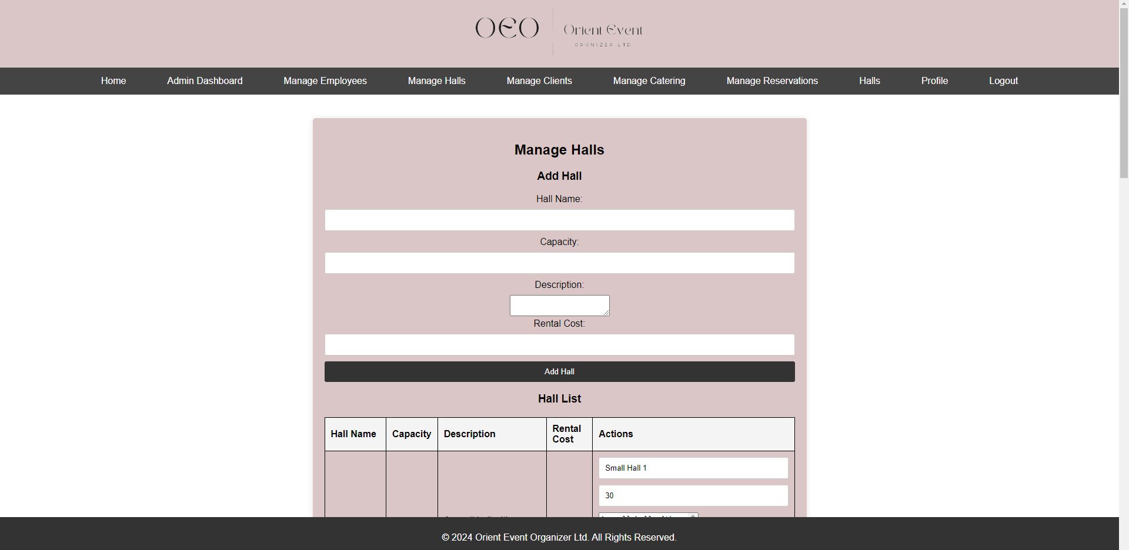

Halls:-

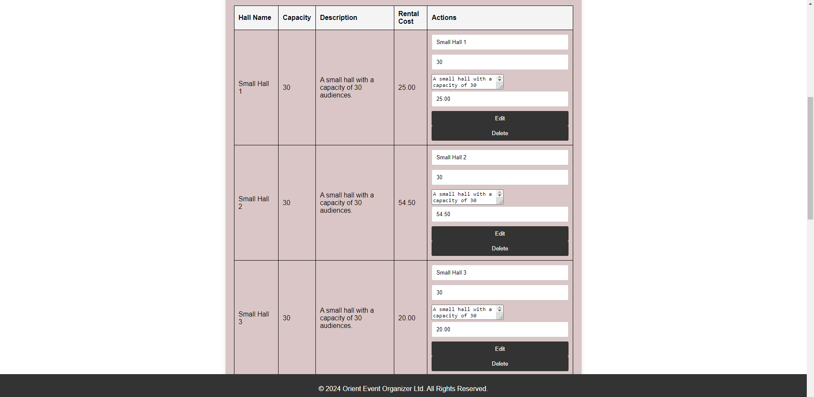

Adding a hall

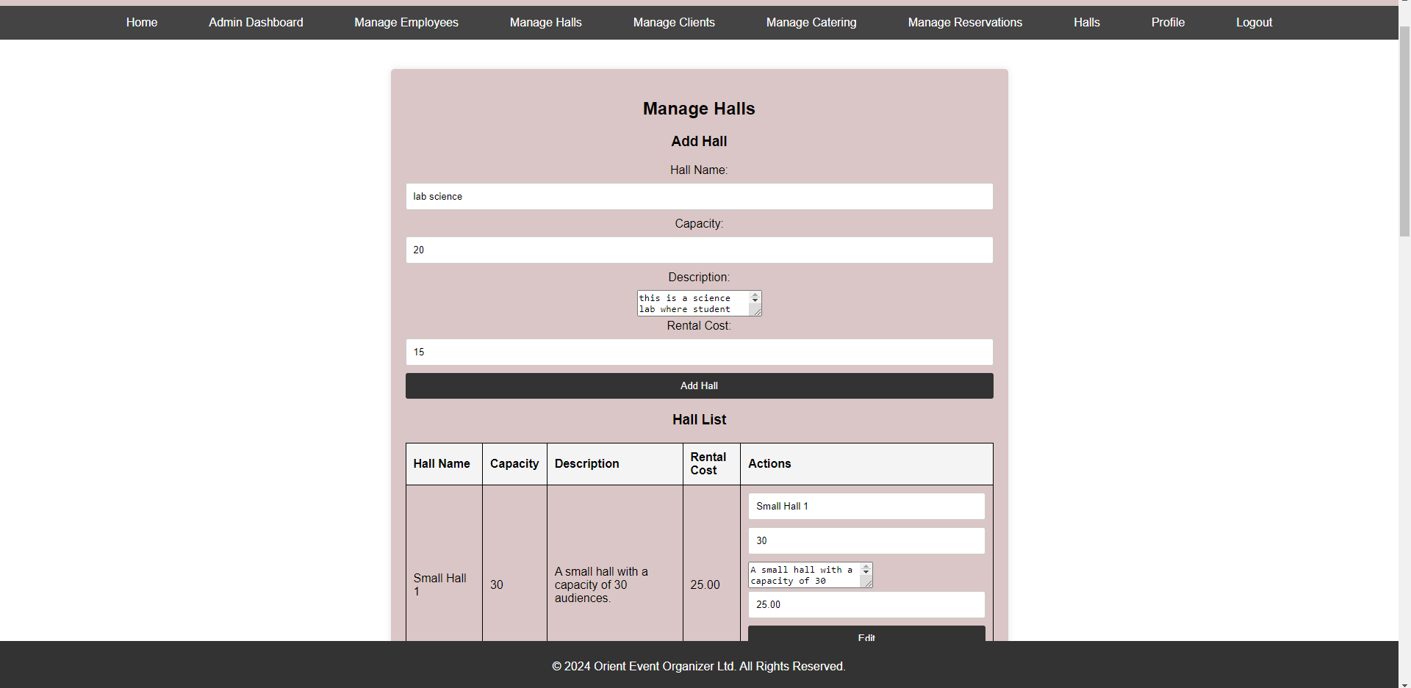



Editing Rental Cost 15 to 18

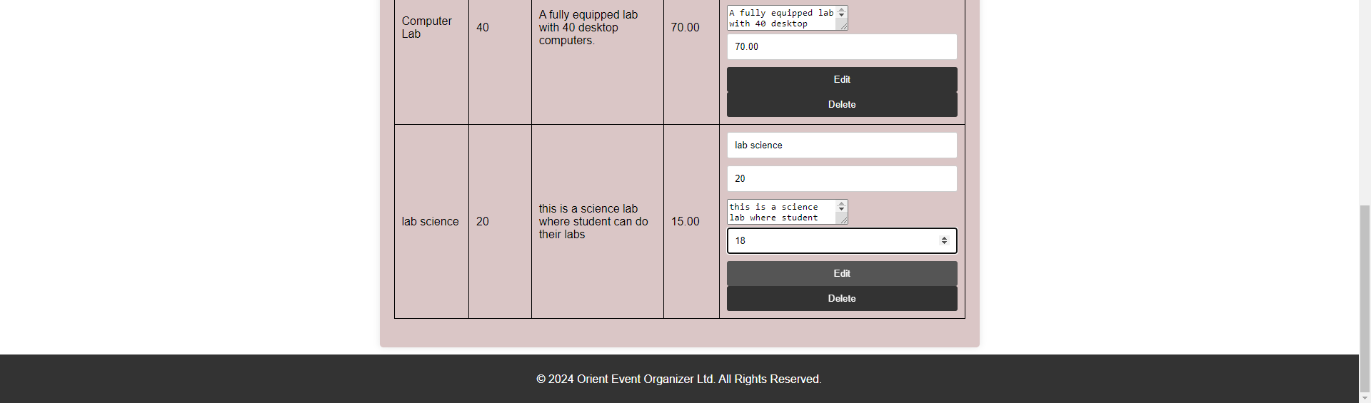

Edited successfully



Deleted “lab science” successfully:-

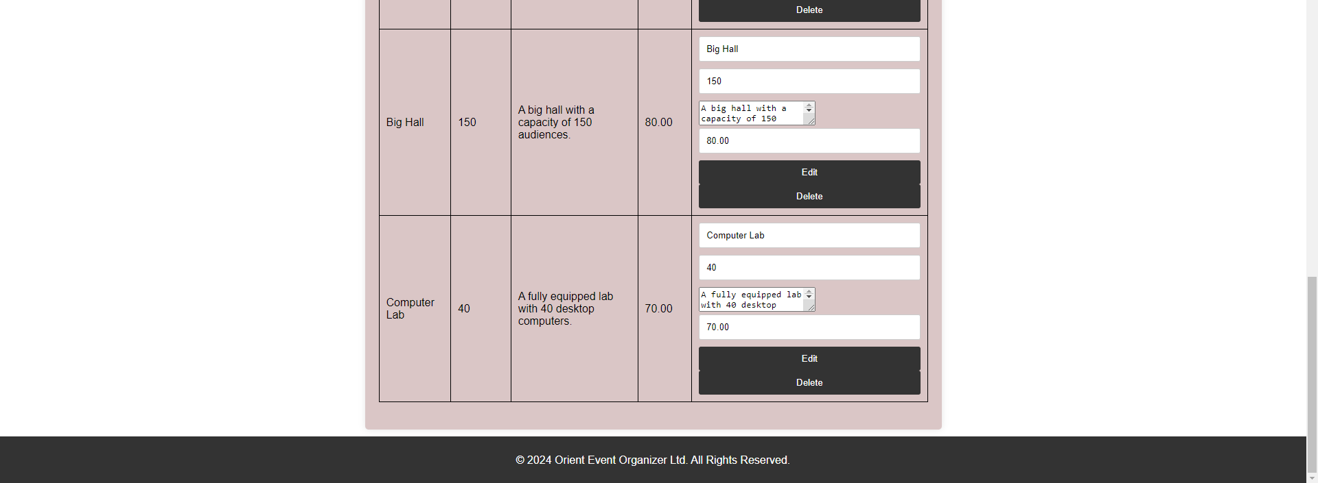

# **Manage Clients(Add/Edit/Delete)**

The Manage Clients page within the Online Event Management System enables users to efficiently oversee client information. This page allows users to add new clients, view detailed client profiles with an intuitive action section, users can easily edit or delete client information as needed.

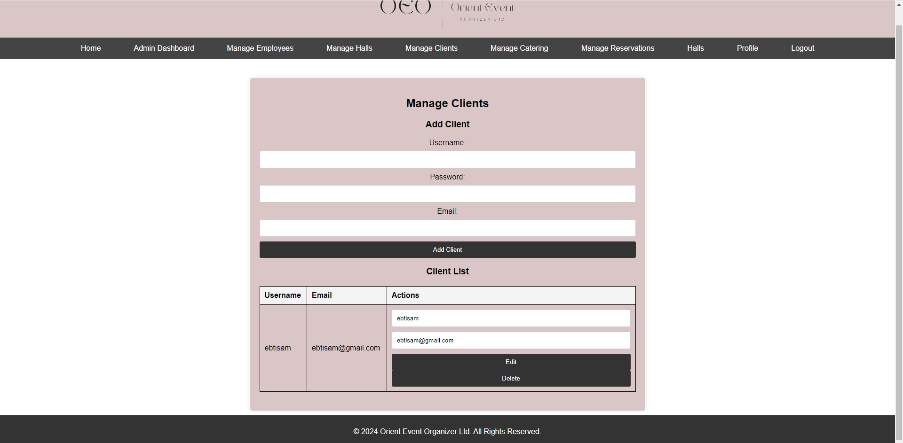

Add client “fedda”:-

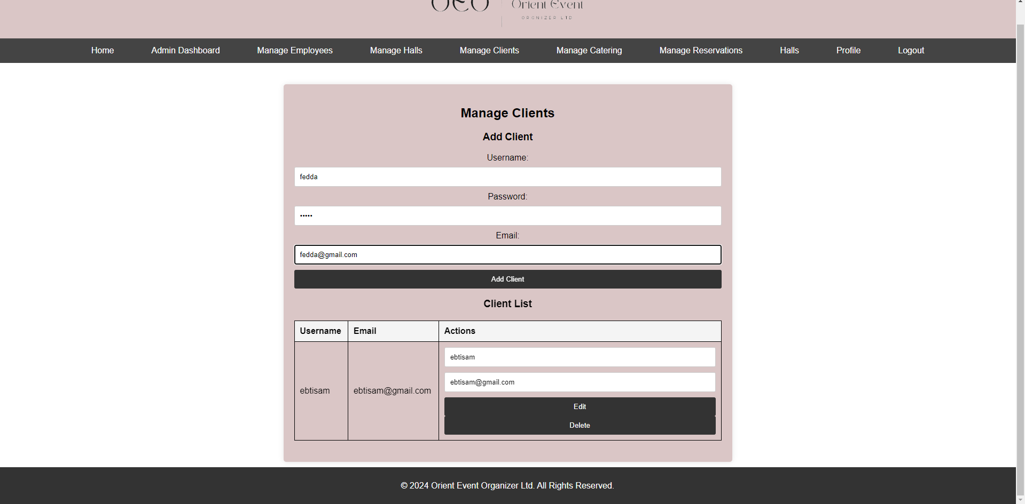

Password validation must more than 6 characters :-

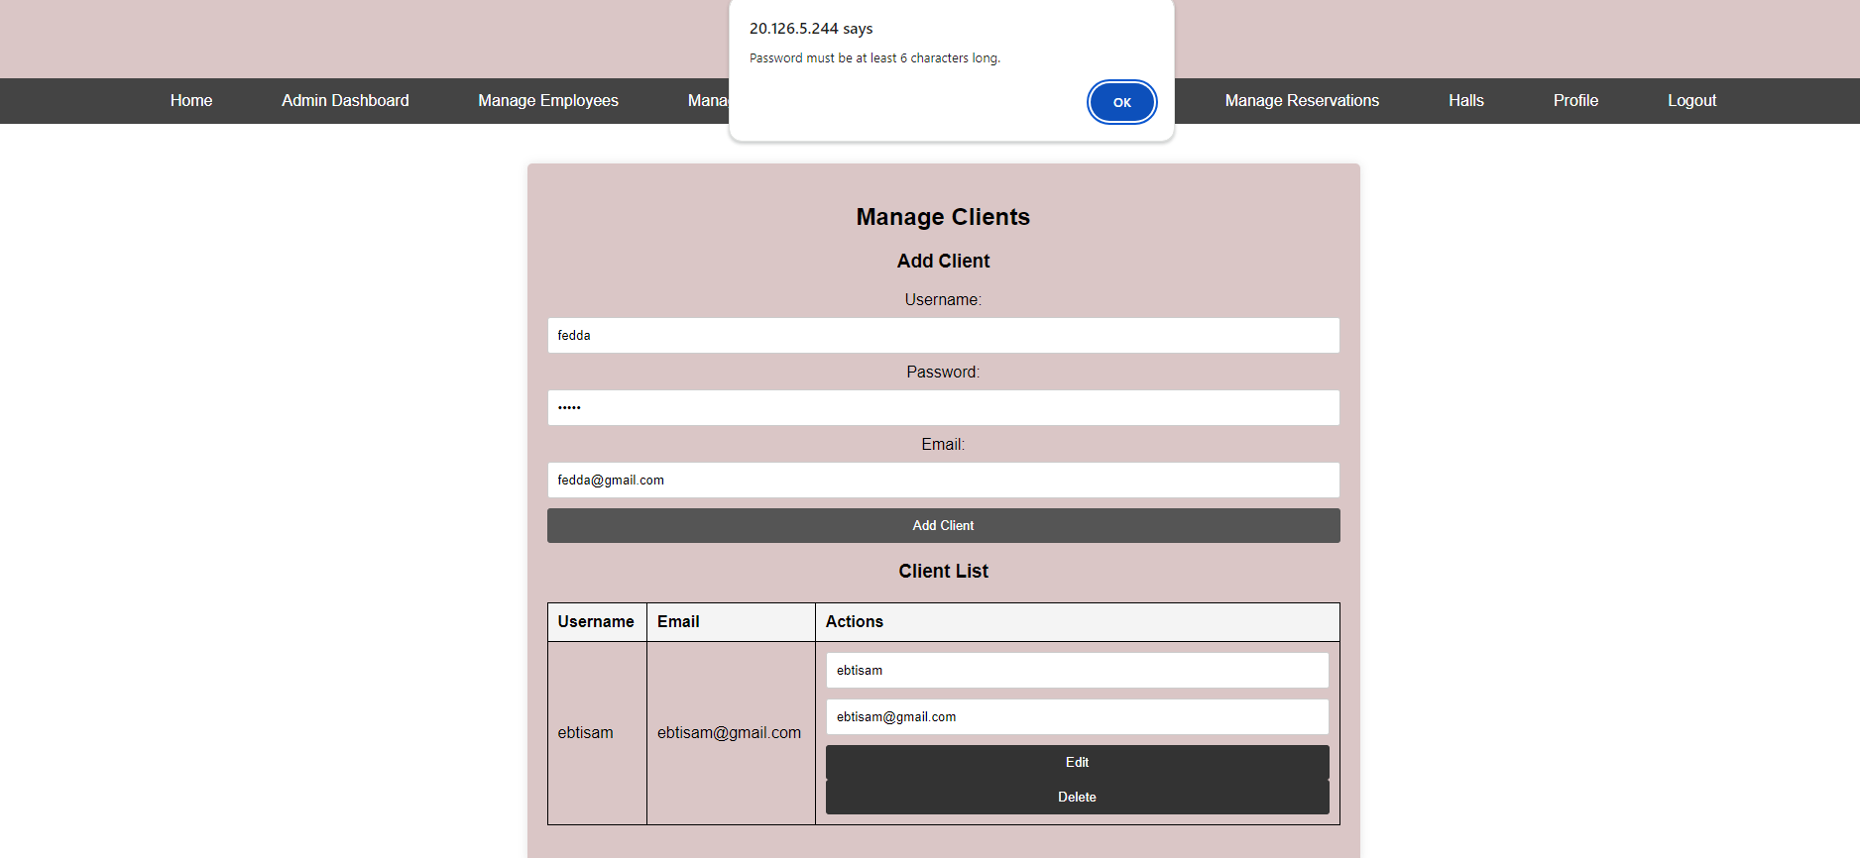

Added successfully:-

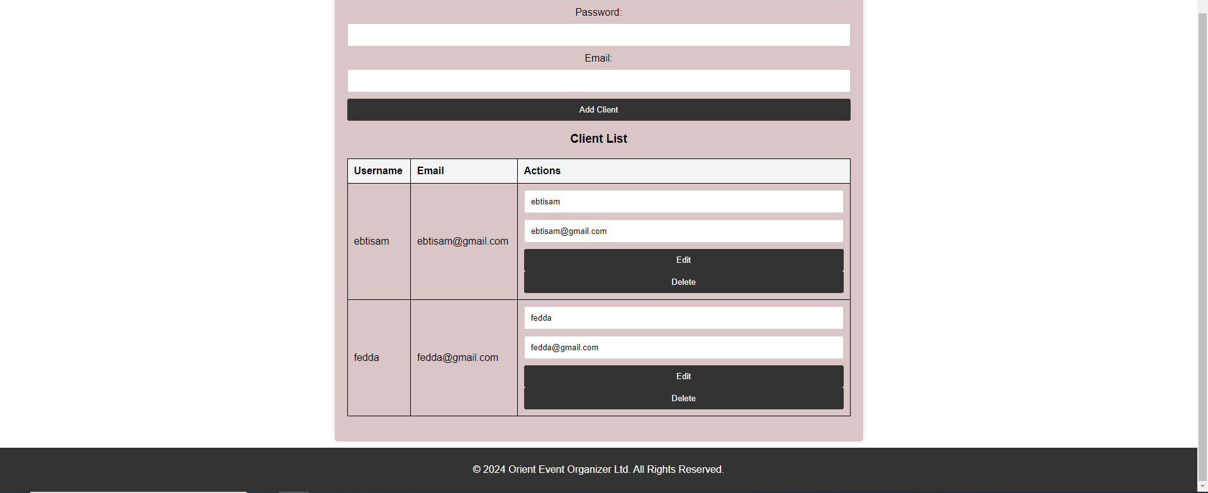

Edit email of client “fedda”:-

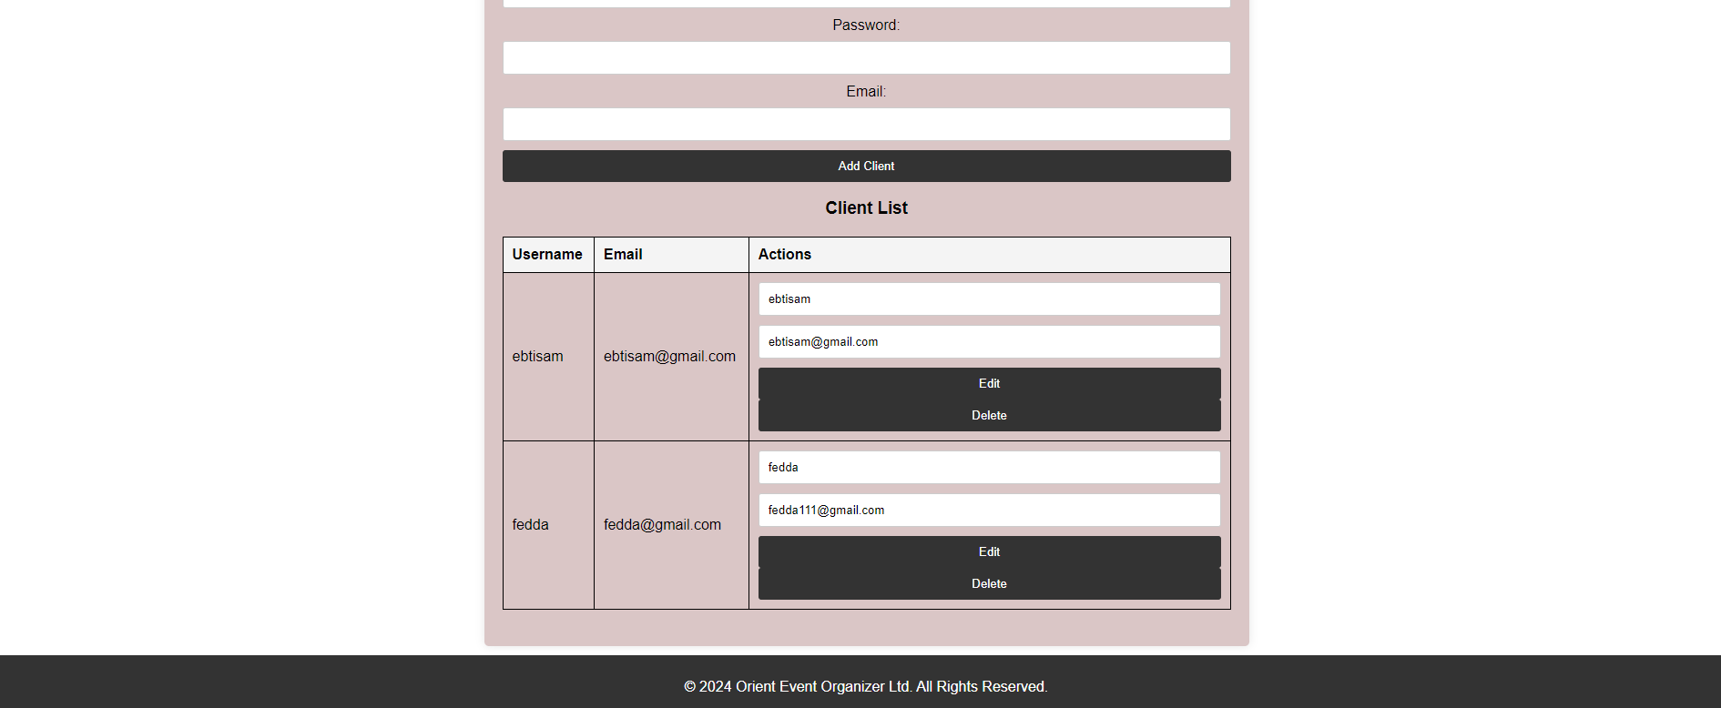

Edited successfully:-

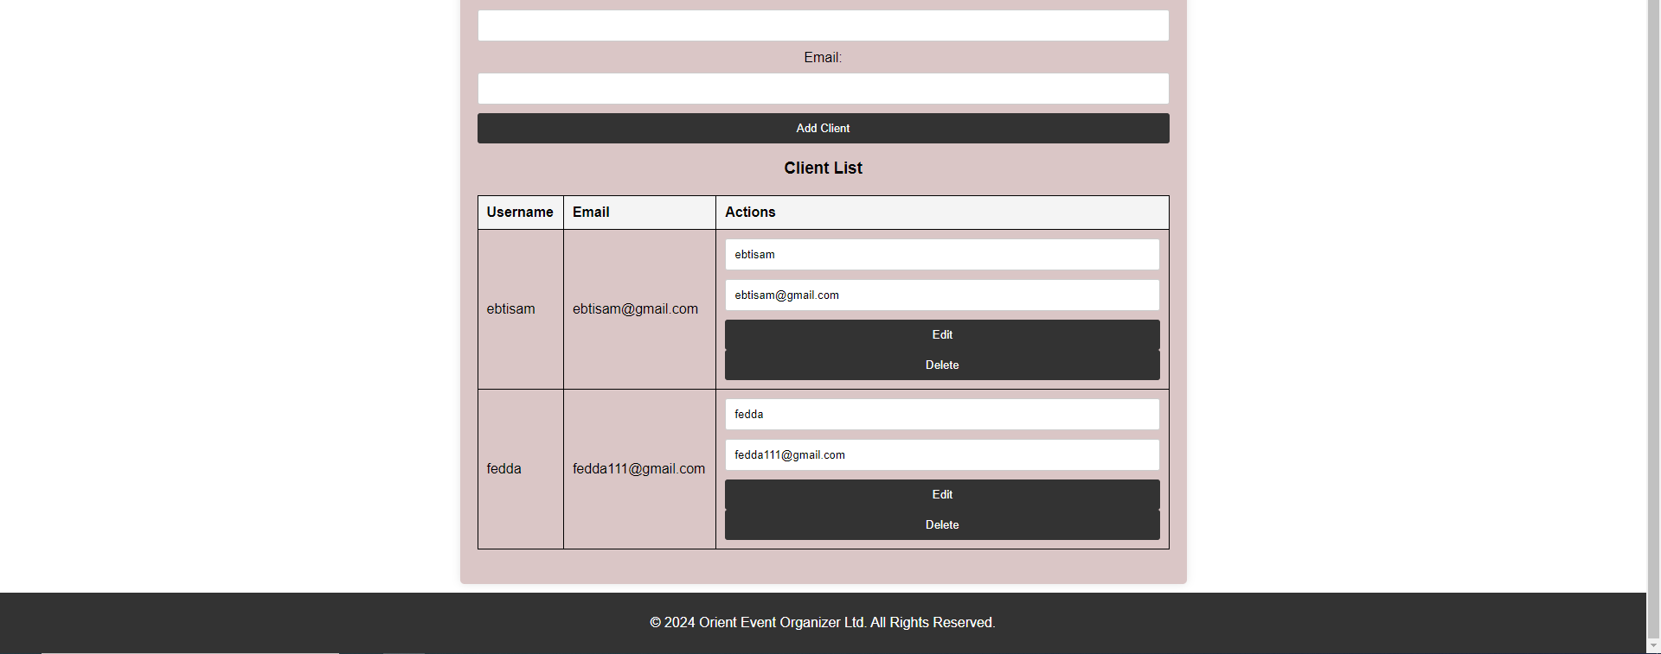

Delete client “fedda”:-

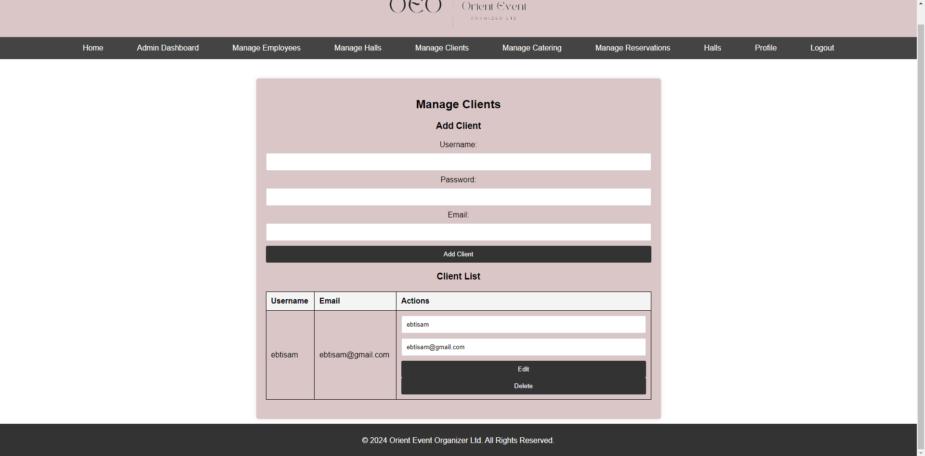

# **Manage Catering(Add/Edit/Delete)**

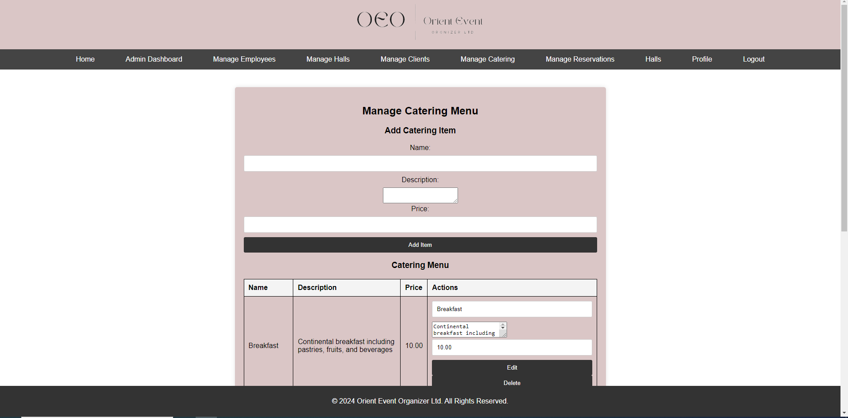

Adding information for catering:

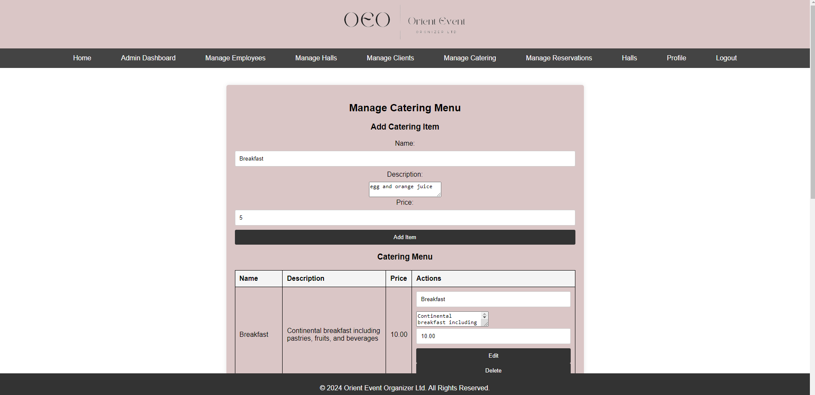

Added successfully:-



Edit price from 5 to 6 successfully:-



Deleted successfully:-

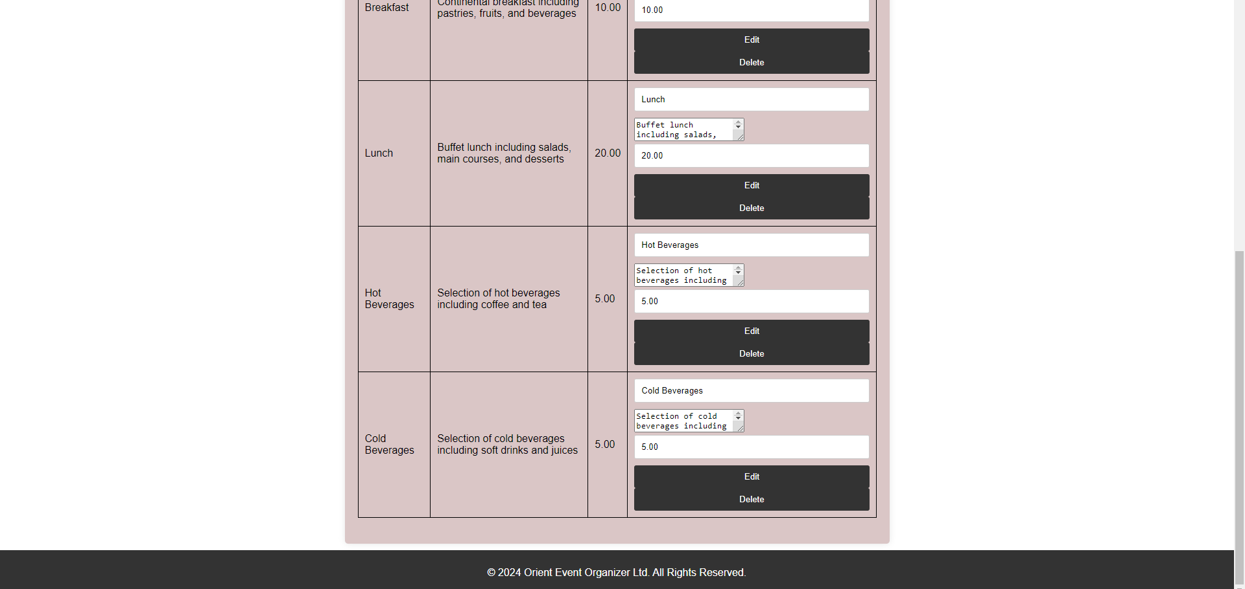

# **Manage Reservations(Edit/Delete)**

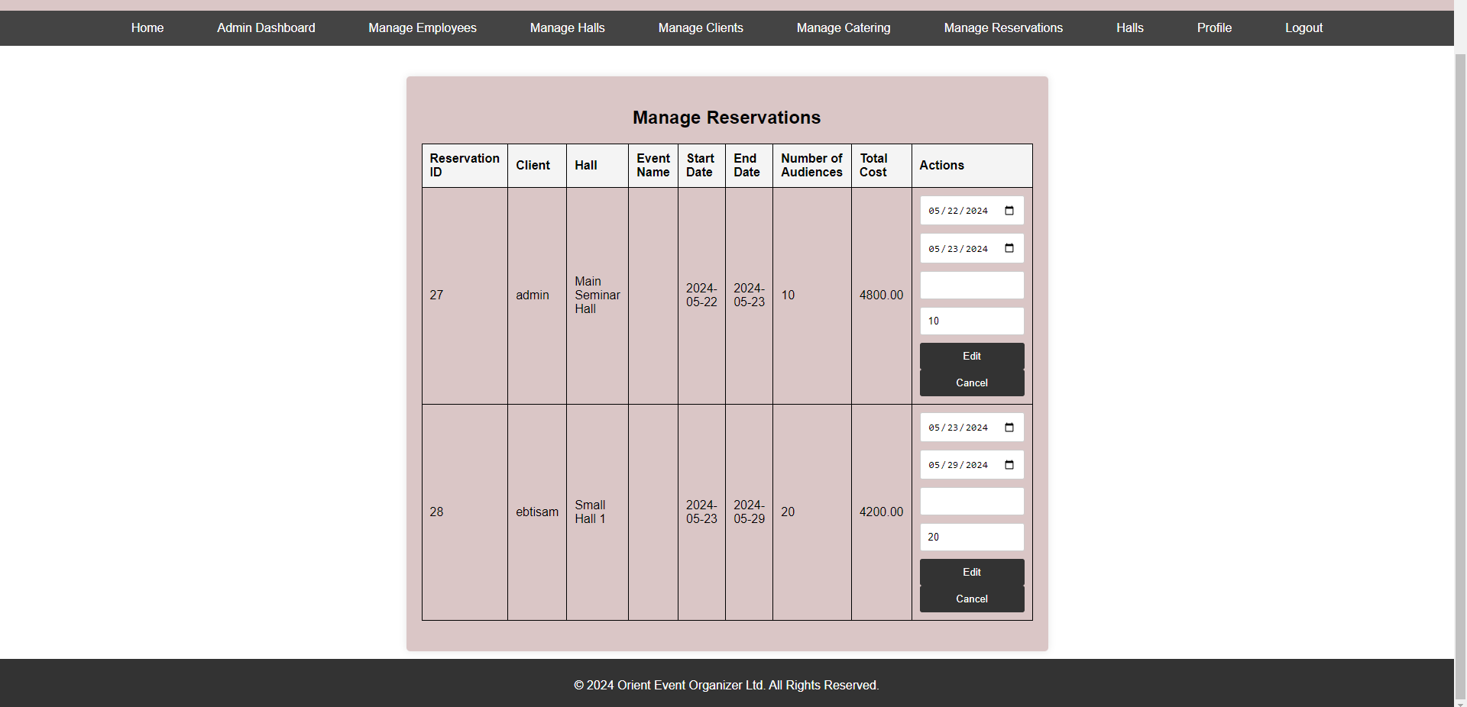

# **Employee portal**

Home page of the employee. Include the same pages as admin put without manage employees privileges.

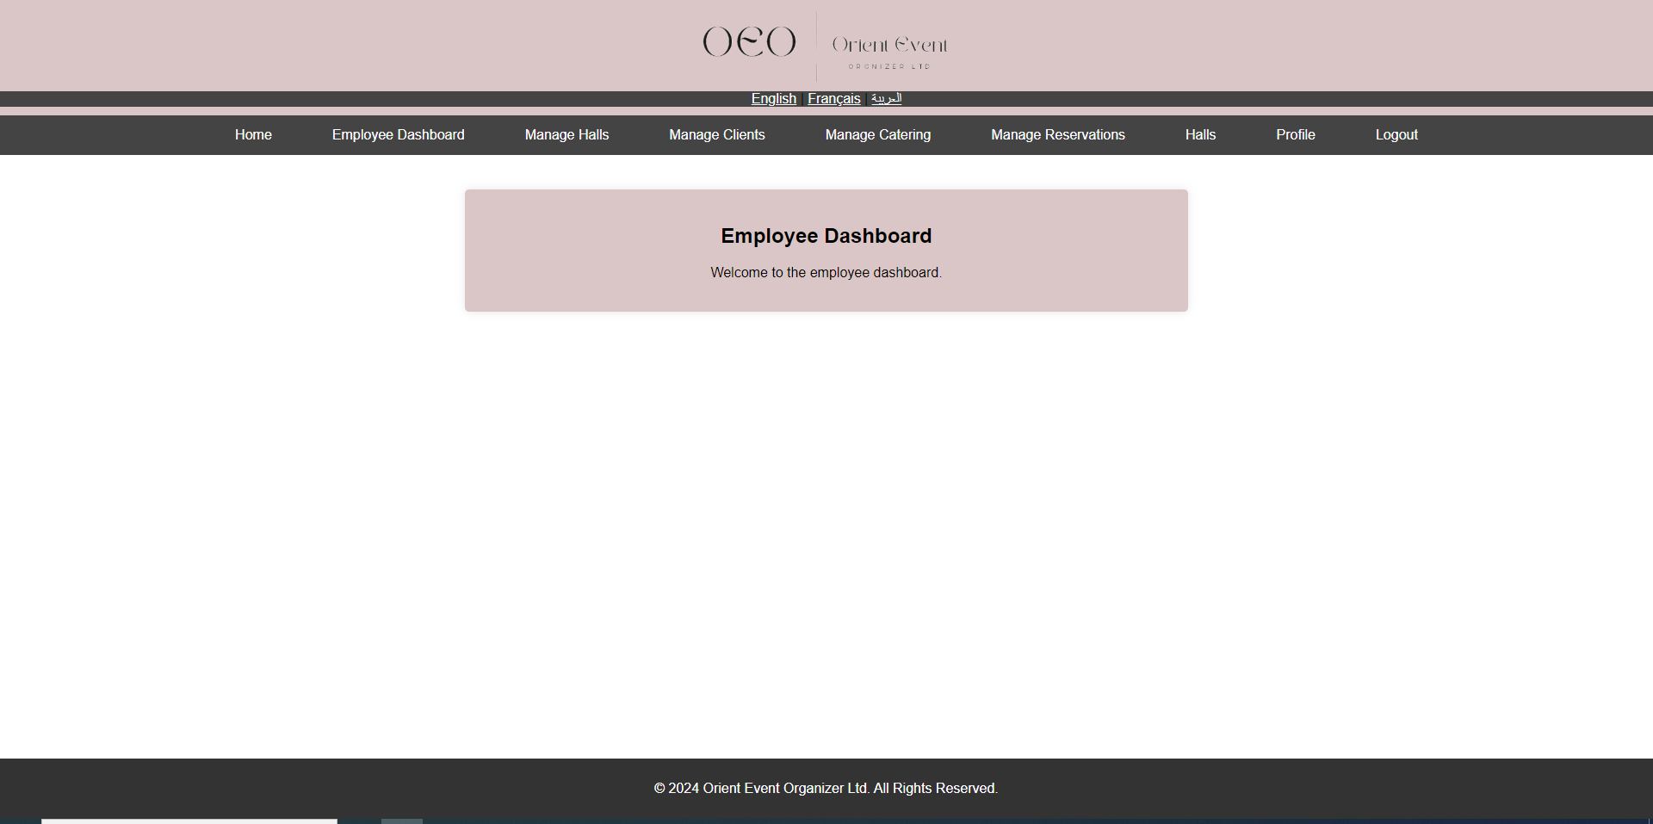

Employee profile

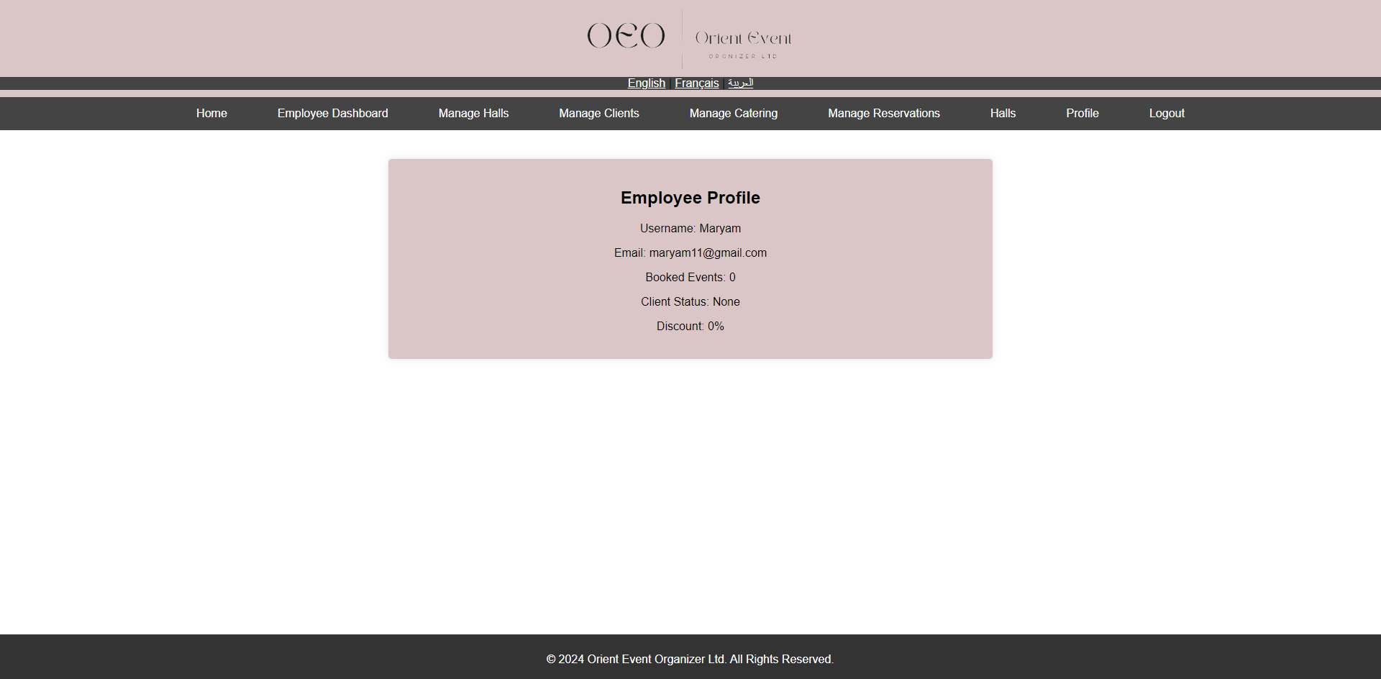

# **Client portal**

Home page of the client.

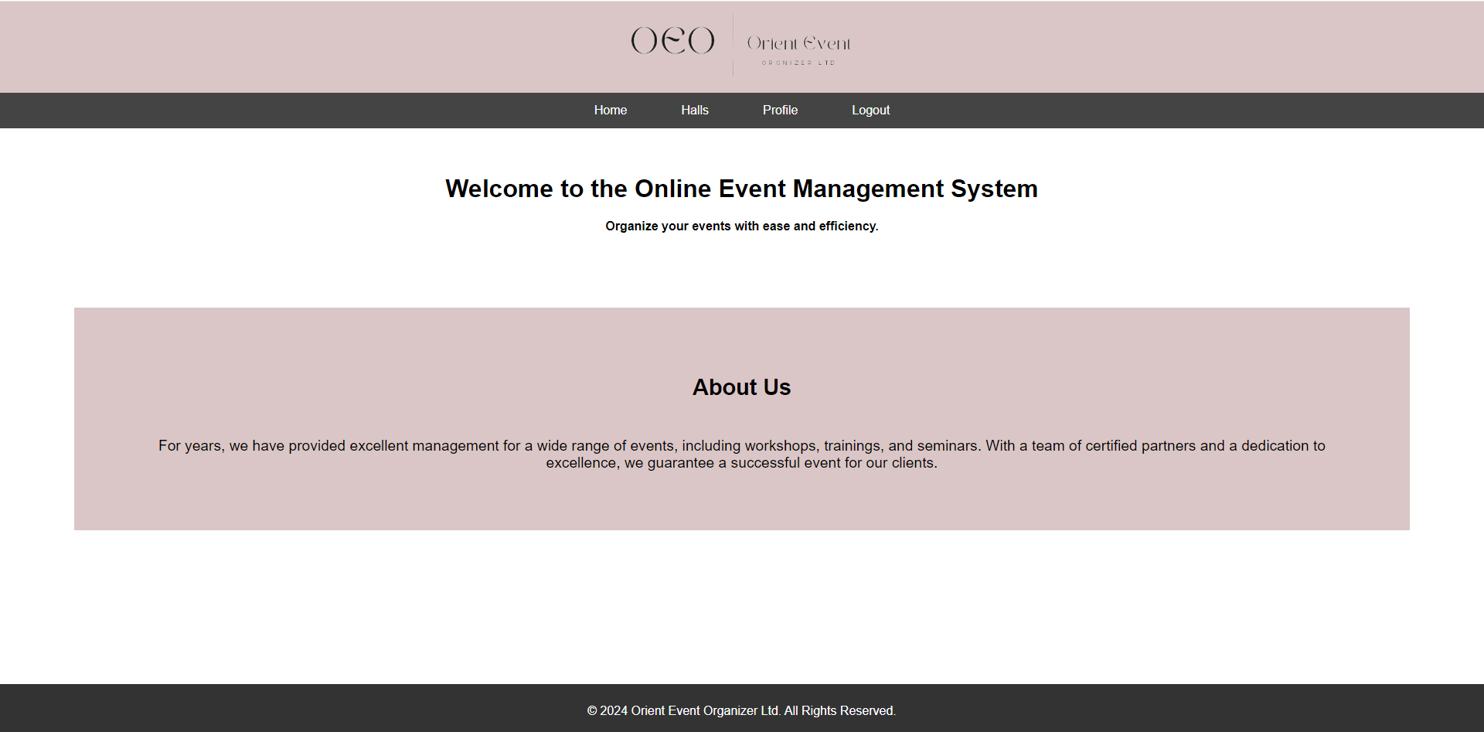

Client profile

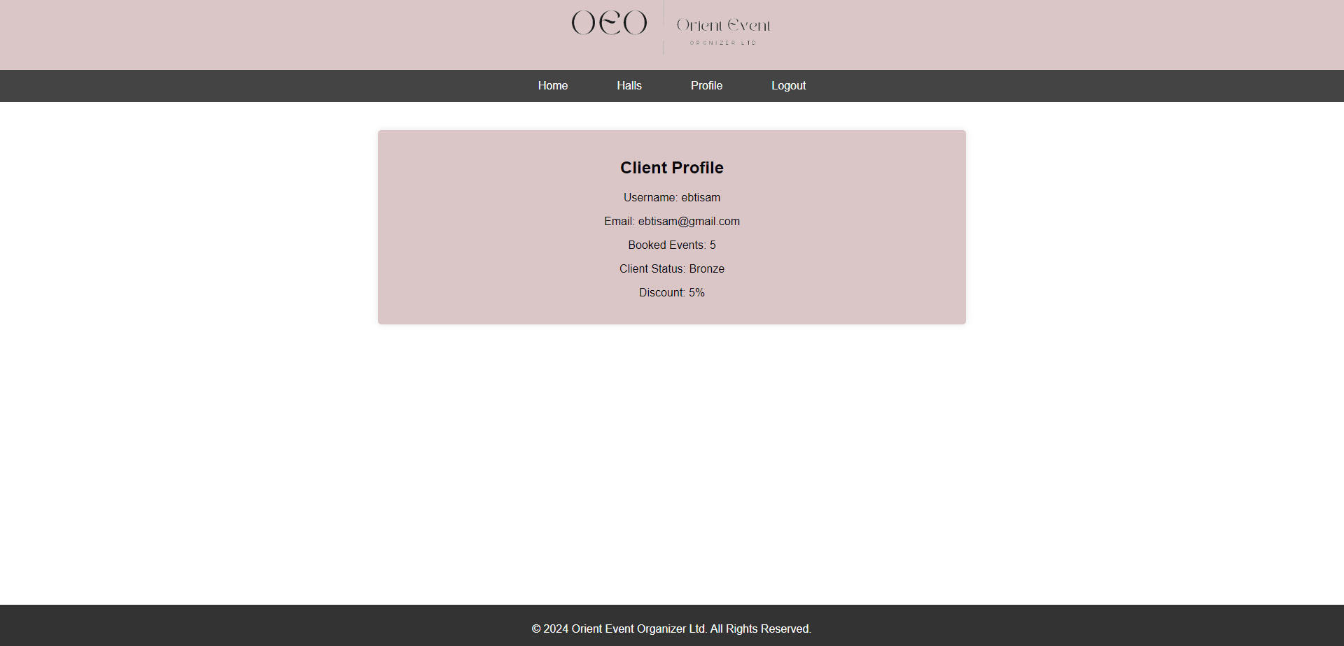

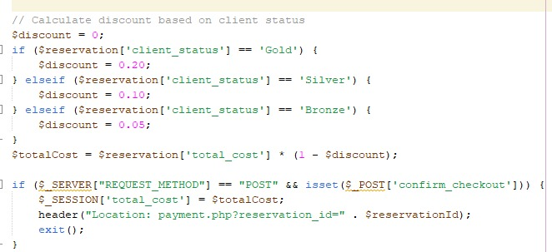

Client status none after only one event booking:



Client status Bronze after booking more than 5 events and will get a discount of 5%, so the total below changed after discount.

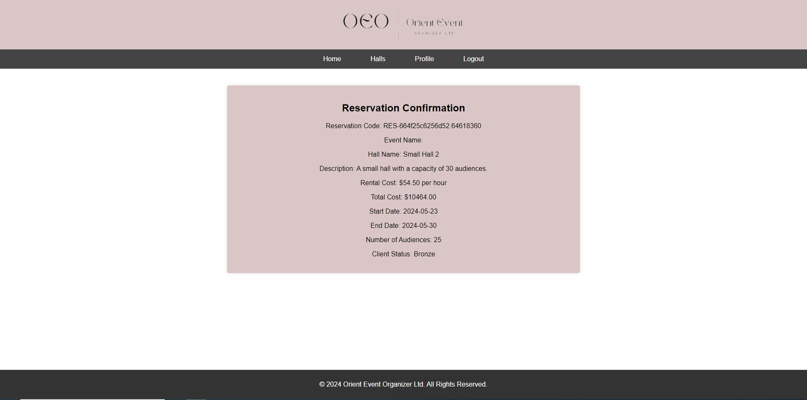

Client status Silver after booking more than 10 events and will get a discount of 10%, so the total below changed after discount.

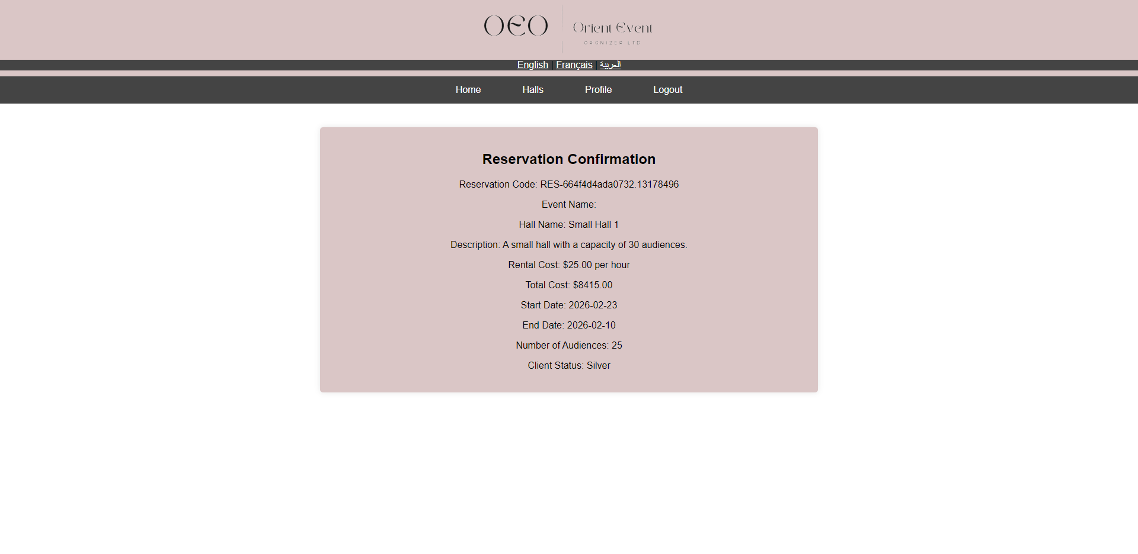

Client status Gold after booking more than 15 events and will get a discount of 20%, so the total below changed after discount.

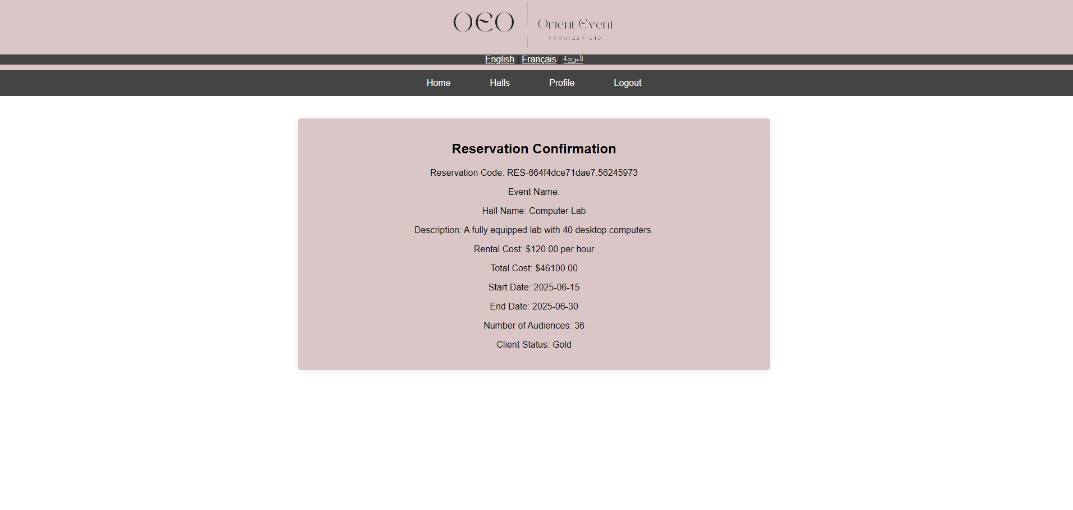

After client reserve event, a selecting catering service page will be shown to select from

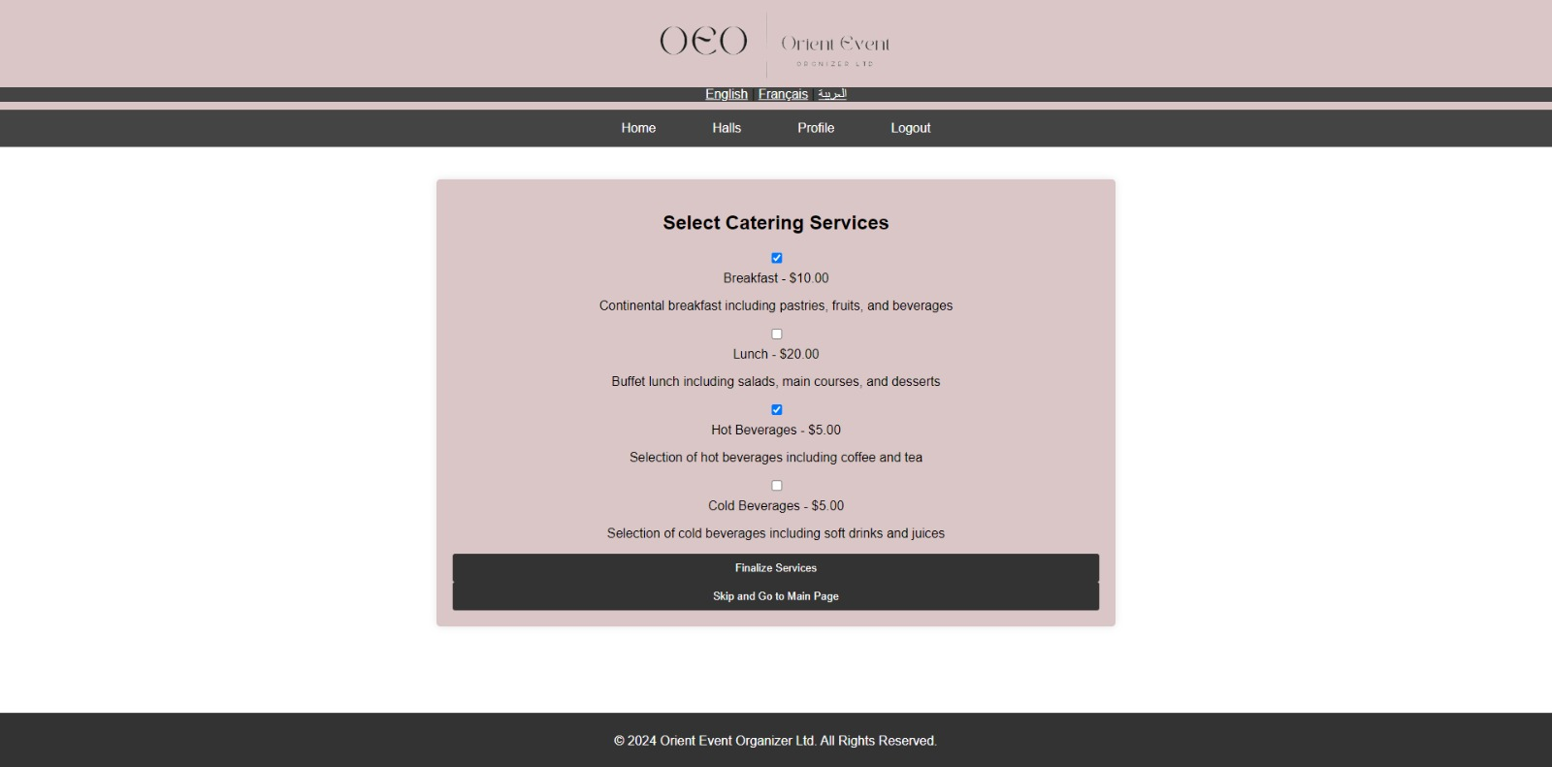

After clicking on the “Finalize Services” button.

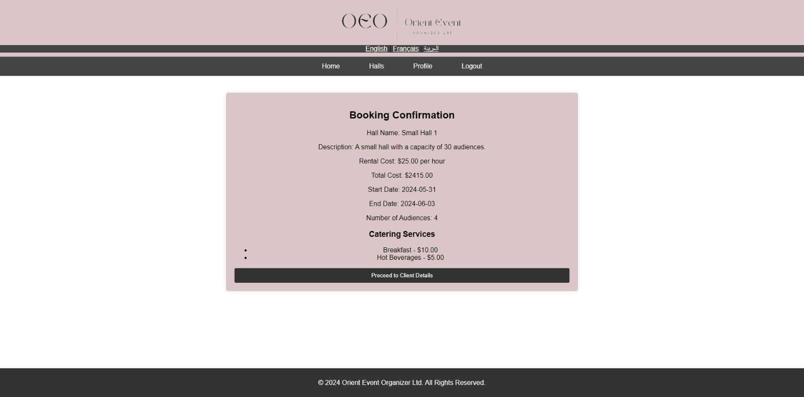

After clicking on the “proceed to client details” button the total will change after discount 5% of the client.

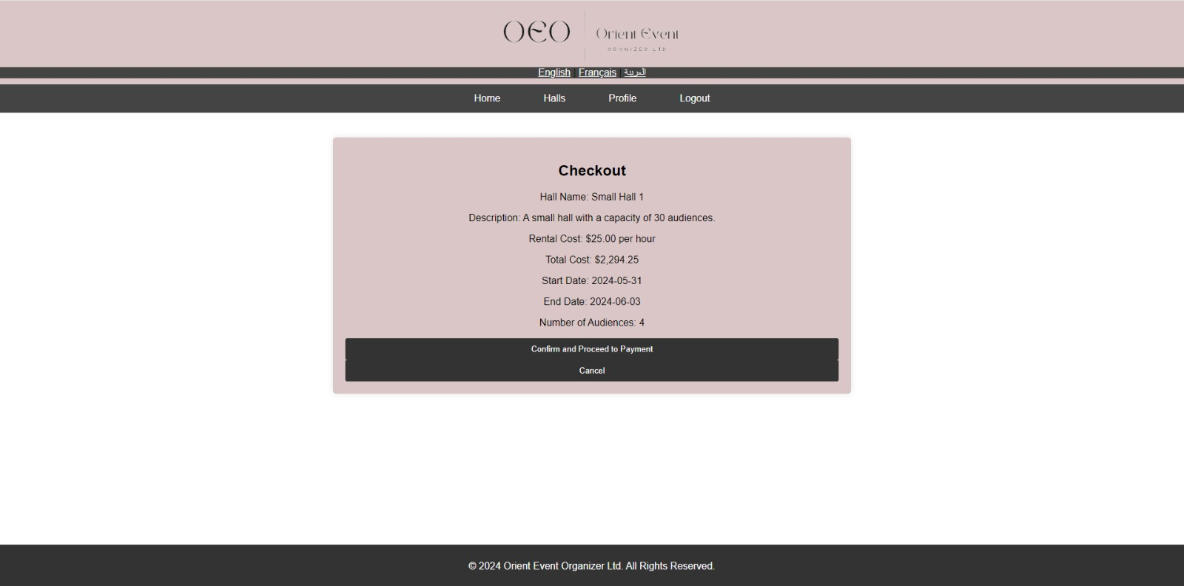

Client view halls:

After clicking on “Reserve a hall” to search

